Dido Maulana

Contents

1.Background and Investigation 2

1.1.An introduction to the organisation 2

1.2.Description of the current system 3

1.3.Identification of client and users 5

1.4.Business Case for Change 6

1.5.Evidence of the use of relevant investigation techniques (Appendix B) 7

1.6.Client Requirements 11

2.Analysis and Deliverables 12

2.1.Statement of Scope 12

2.2.Description of the proposed system 14

2.3.Documentation of the Process 16

2.4.Description of The Users of The Proposed System 19

2.5.Evaluation Criteria 20

2.6.Agree Deliverables 23

3.Design and planning for implementation 24

3.1.Draft Design Work 24

3.2.Final Design Work 35

3.3.Plan for Implementation, Testing and Instalment, Including Proposed Time Scales 44

3.4.Training Requirements of The New System 45

3.5.Testing strategy 45

3.6.Test Plan 46

4.Testing documentation of the implementation 49

4.1.Evidence of Testing 49

4.2.Evidence of Client and End User Testing 65

4.3.Comprehensive Documentation of the Solution 67

5.Evaluation 67

5.1.A Critical Evaluation 67

5.2.Evaluation of Own Performance 68

5.3.Evaluation against Client Requirements and Evaluation Criteria 70

# 1.Background and Investigation

## 1.1.An introduction to the organisation

NorthAir is a little flight school located in the growing little town called Al Khor, located 60km off the capital city Doha. The company has been providing flight lessons for over 3 years.  
The school starts at 7 in the morning and the latest lessons will end at around 8pm.   
They have been recently acquired an extra budget in order to invest in their system, and the owner Mr Saleh Sheikh wants to improve their current way of making the timetables for the instructors and the students. The school owns 10 “Cessna 172” planes - one of the most successful mass-produced light aircraft in history with well over forty thousand rolling off the production line, which are all used for the flight lessons. NorthAir currently employs 8 flight instructors and the school charges 650 riyals per hour including the costs of fuel and instructor costs for lessons in daylight, the school will charge 750 riyals for flight lessons at night due to the higher risks for new students flying in the dark. Students who wants to apply for the lessons has to book it by filling out a form which will be given to the receptionist– who will confirm if he is available for booking at that time. The school currently employs 20 people including Mr. Sheikh, with 8 of them being the instructors and 1 receptionist that sort out all the timetables. The last 10 consists of 2 cleaners, 4 working in accounting department and the last 4 working with the human resources. The main man working behind the scene is obviously Mr. Sheikh. He is the owner of the school and he makes most of the strategic and tactical decisions. As it is still a fairly small school, the task is not as overwhelming as it sounds, he also handles the hiring of any new instructors or employees personally, but as he is looking to expand the task will get harder for him.

## 1.2.Description of the current system

The current system is paper based. A student who wants to apply for a lesson fills in a form with his/her own details, which instructors would you like to instruct you, and the duration of the lesson. In any case where you don’t get your preferred instructor, an instructor that is available at your desired time will be filled in with the lesson. This form will be given to the receptionist, who will confirm the availability of the instructor – where you decide what time you want to start the lesson. The receptionist has to manually create a timetable for the instructor and student which can be printed out for the instructor and the student; again it will be done manually by the receptionist. When all is done, the receptionist will print out a receipt for the customer which he has to pay fully stamped before attending the lesson – the receipt also tells the student what time and which instructor he/she has booked for the lesson, when paid and stamped – the student is required to bring this receipt to the instructor. This receipt is then stored with the form given by the customer to the receptionist in the filing cabinet which is sorted out by day of booking. This is all done in the 2 floored office building with each office of all the personnel (receptionist, instructors etc.) all fully equipped with a computer that is connected to the internet. The drawback of this system is the fact that doing this manually is very time consuming therefore inefficient use of valuable time. It’s not exactly difficult to create the timetable but if you have to do it manually for each lesson then it will certainly consume time. Another drawback would be that using a file cabinet takes up a lot of physical space and it is fairly difficult to try and find information from the past.

**Asking for a timetable**

|  |  |  |  |  |
| --- | --- | --- | --- | --- |
| Input | | Processing | Output | |
| **Student fills in form with his/her own details and also choosing which instructor (if preferred), how many hours and when would you like it to be arranged.**  **Booking a lesson** | | ***Form given* to the receptionist who will check their online booking system to check if the planes and any instructor are available for that time. If no instructors are available then student will be asked to change time.** | **Receptionist confirms availability of lesson, gives the student a paper-check receipt to be paid.  When paid then the student is required to bring this receipt to the instructor when attending the lesson.** | |
| Storage |
| **Your information on the form will be stored by the receptionist to create the timetable.** |
|  |
| Input | Processing | | | Output |
| **Student goes back to the receptionist/ emails the receptionist with proof of receipt stamped and fully paid.  Student asks for a timetable.** | **Receptionist finds student’s form with information on it.  Confirms it from the receipt.  Starts creating a timetable from a set template.  It usually takes 5-10 minutes to generate a new timetable, depending on how many lessons the student has book for.** | | | **Receptionist gives timetable to the student or it can be emailed to the student.** |
| Storage | | |
| **Once you have paid, the receptionist will take note of this and tick the “Paid” box on the form.** | | |

## 1.3.Identification of client and users

**Client**  
my **client** is the owner of the flight school, Mr Sheikh who has asked me to create the database system.  
He is the one that does the strategic plans and he was the one who felt that the system wasn’t efficient enough for the school’s ambition to expand. Mr. Sheikh felt that an upgrade in the system would come a long way towards helping their expansion. He felt that the paper based system was far too time consuming. He has also received complaints from the receptionist regarding the system due to the increasing number of students going to the school.

**User**  
the **user** that will run the system will be the receptionist that will use the system to store the information of lessons, students and instructors.

**Mr Joe Miller – Receptionist**   
An experienced worker who has worked in London for a similar business for 2 years previously before joining NorthAir Flight School. Mr Miller is very used to the system as he has done over 200 timetables for the instructors. He is the user of my system and has personally felt that his workload has been constantly increasing as he is the only receptionist that takes in the information from students. He felt that the paper based method was too tiring and time consuming. He was also aware of the available technology used by other flight schools to book lessons for the students.

**Audience**  
the **audience** is the students and instructors as the final report will be for them.

In this project I will analyse the receptionist who will be using the system. He has been using the paper based system for a while now and he will certainly help me in terms of how he currently views the system and what needs to be improved.

## 1.4.Business Case for Change

The current system involves around producing manual documents from a paper based system. As previously stated the current system has major drawbacks that can certainly be improved to make life a lot easier for the secretaries. The functions of the current system are not efficient enough, therefore the company really requires a real upgrade to its system – not only to make work done more efficient, companies that uses the more advanced technology tends to look better for its own reputation for its reliability.   
The new system would feature more advanced functions in order to meet the needs of the receptionist to gain maximum efficiency for their work. The features of the new system will be things like the ability to automatically generate timetables from the database system, options to print it or emailing it, also automated electronic receipt for the customer both which will have a set template. For block booking customers, they are able to access the option of getting a timetable. It will also be easier to modify entered information into the database as everything can be easily accessed and changed if you want to. Since everything will almost be stored electronically, backup plans can be easily arranged to prevent disastrous loss of data in case of any emergency. It is also a way to efficiently save office space – with everything stored electronically the receptionist won’t be relied on storing the paper form or receipt, which can be easily lost or get mixed up with other paper works. It will also help the instructor and the student a lot as now the receipt and the timetable can be immediately produced through the new system.   
Economically it will be also be more efficient in the long run. The elimination of paper forms will save them safe and won’t require them to get as much stationaries as before. The initial hit will most likely cost NorthAir some money, but the new system will definitely be a foundation of their expansion.

## 1.5.Evidence of the use of relevant investigation techniques (Appendix B)

Investigation 1 – Questionnaire

I will now research more about how the instructors benefit from the output of the system, how reliable they are and if the timetables are actually effective. I will give them questionnaires relating to how the timetables work. This questionnaire won’t be given to the students because the timetable benefits them both in a similar way.

* On a scale from 1-5, how reliant are you on the timetable? 5 being very reliant

This result shows that most of the 8 instructors are very reliant on the timetable therefore improvement on this department is essential for employee satisfaction.

* Do you think the timetable takes too long to generate? Yes/No/Sometimes

Out of the 8 instructors, 7 of them stated that the timetable takes too long to generate, again shows that it is necessary to improve upon this department.

* On a scale from 1-5, how often do you get a wrong timetable? 5 being very often

Out of the 8 instructors, 7 of them stated that the timetable takes too long to generate, again shows that it is necessary to improve upon this department.

* Do you like the format of the current timetable?

Shows that the current format given out is good enough for most of them, major changes are not necessary on this department.

* Do you think it would be easier to have your timetable emailed to you?

Clearly that all of the instructors thinks that the timetable is too blunt and can be improved. It is a clear 8/0 voting in this case.

Investigation 2 – Interview

In order for me to know more about what Mr Sheikh wants from my system. How it will be implemented, where the backups will be stored, which storage device to use. These factors will be discussed during the interview.  
I will be suggesting to Mr Sheikh of how I think he should carry this out, what kind of hardware he needs and other professional IT problems that might occur.   
An interview is the best way to find out about these things as it allows me to ask more open questions. Appendix A

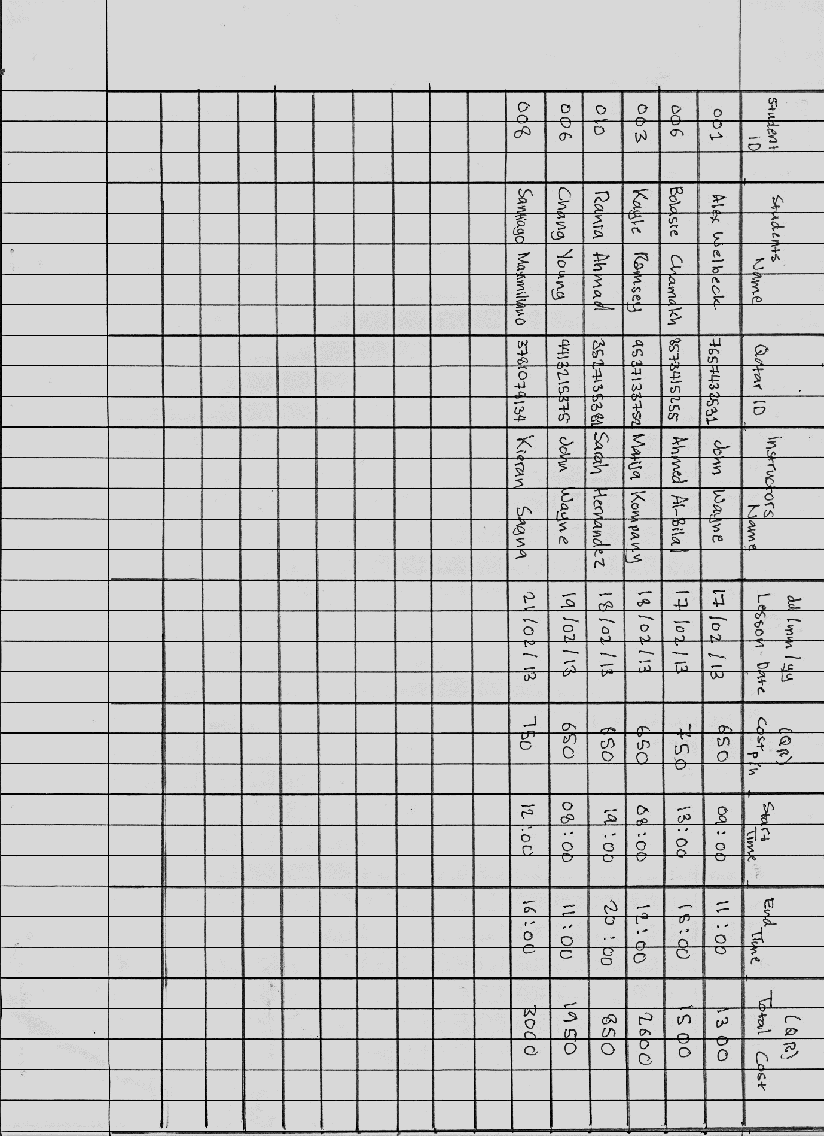Investigation 3 – Document Analysis

Now I need to investigate how the current system works using documents analysis. Mr Miller is willing to show me how he completes a booking for a student. This allows me to see how the data is input into the system, what’s being processed and what do you get from it.

## 1.6.Client Requirements

1. The system should have a functioning database system that can hold the information of the students, instructors and lessons.
2. Must include listed fields from the previous system, with any suitable additional fields that relates.
3. System should have an inbuilt form in order to make data entry into the database easier and at the same time prevents errors.
4. The form should be designed using the company’s theme, including the logo and colours in order to make it look more professional.
5. With the inbuilt form, there should also be a paper type form made for the system in order to collect information from the students and instructors.
6. Any necessary instructions should be included within the forms in order to make it easier to fill
7. The system should include a suitable search function so that the user can create different lists with different criteria but mainly the desired documents
8. This search function should also be able to calculate the total cost of the lessons for each students using the duration of lesson (hourly) and the price per hour.
9. The system should also include a certain template for the timetable and the receipt, the timetable must be set into a suitable tabular format so it is easy to read, it also has to include suitable information about when or what time the lesson is etc. For the receipt, it has to include the total price of the lesson and what type of lesson the student is taking. Both of them has to be made using the company theme.
10. The timetable and receipt must also be able to fit A4 size as it might be required to be printed out
11. Contains sufficient amount of instructions and shortcuts on the form.
12. Include a help file with all the guides on the function of the system
13. The instructions within the system should look good with the form (basing on the colours and theme)

# 2.Analysis and Deliverables

## 2.1.Statement of Scope

There are some constraints that has to be considered for the proposed system. Based on the results of my interview with both the receptionist and the client I can conclude that they have several internal and external constraints that needs to be considered and dealt with. Internal constraint is basically a restriction that is within the system, whilst for external it is a restriction that is outside the system.

**Software**

One of them is having the right software for the system – in order to run the system requires Microsoft Access and Word, the software is available at the school – but it is not updated to the latest version. The latest version of the software features an interface that is a lot easier to adapt to, this will help to accelerate the process of adaptation for the user due to the fact that the new one is more user friendly.

**Training**  
This issue also links to the fact that staff has to be trained in order to run this system in order for them to be familiar with the features I will include to make it a lot easier and faster for both them and the students. The receptionist has stated that he is fairly good navigating around access, but not too familiar with it – so training should be essential. Luckily the system runs more efficiently with one person running it so that bookings can be done faster, therefore it won’t cost them too much training the receptionist.  
**Hardware**  
In order to run the system smoothly – there are hardware requirements. The hardware the school currently runs; Inter Quad Core 2.4GHz equipped with 2GB ram and a storage capacity of 300GB. These specification are more than enough to be able to run the system smoothly. The set of computers are equipped with a 19 inch HP L1909wi monitors with basic features of adjusting brightness and contrasts – important in preventing eye strain. The school also has a HP Laser ColorJet CP5225 which is more than good enough to print the data capture forms and any future timetables and receipts. Investment in ink will be needed though as the printer will be an important part of the system. The receptionist table is equipped with a simple computer chair that can be adjusted to be lower or higher with comfortable back support. Important to prevent back injuries.  
**Security**  
Security is also an issue as the receptionist stated that he does the work on a shared computer with no password protection. With the new system being 1 single access file it will be easy for information to get stolen therefore having a password protected computer would prevent this from happening.  
**Backup**  
Another constraint is backing up the data. The school has no actual solid data backup plan as most of the stuff they do are done manually. It is important to have a solid backup plan for this system as all of the stuff will be stored electronically to prevent major data loss.

**Law**An external constraint that has to be dealt with thoroughly to make sure that the business doesn’t violate any rules set in the country. In this case it will be mainly copyright. Copyright is an exclusive legal right that is given to an originator that prevents it to be stolen or copied by anyone else. It is important that any design of logo and colours of the theme for the forms and the company’s general image resemble any copyrighted image. For example using the Qatar Airways logo as the company logo is illegal unless permitted by the company, if found to be very similar the person who has the copyright has the rights to sue and press charges on the person copying, so it is important that the design is original.

**Finances**

Another important aspect that needs to be considered, how much will this all cost? Are the numbers reasonable? Can we afford it? What options are available? Money is always an important aspect and should be considered thoroughly. These is no point of upgrading a system if its too expensive, it is a massive risk to spend all of the company’s resources on one aspect of the business as it will be required elsewhere aswell. So it is very vital that I consider what is needed properly to prevent any unnecessary inefficient spending. In this case my client will definitely need to buy the new version of Microsoft Office for the computer to help the user adapt better as stated above and with the new computerised system, electricity bills fees has to be considered aswell now that the use of computers and printers are constant in the school’s everyday cycle.

**Environment**

Environmental factors are almost an obligation for everyone nowadays, it is very important for my client to be able to clearly identify any factors that can impact environmentally, for example as the printer will be a common part of the system now and it might be necessary to turn it off when not in use just to save electricity instead of leaving it always on, small things like this can help massively in the long run both financially and environmentally.

## 2.2.Description of the proposed system

After my interview with Mr Sheikh, we have discussed several features and factors that will be in the new proposed system. The new system will offer a more efficient way of creating timetables for students and instructors – also a new way of creating a verified receipt to be paid to the cashier.   
This system will be run on the receptionist’s computer which has the same specification as every other computer in the school; **Inter Quad Core 2.4GHz equipped with 2GB ram and a storage capacity of 300GB.** The software it will run on will be **Microsoft Access 2013** for the database and for any mail merge it will be done on **Microsoft Word 2013**. Previously the school runs on Microsoft Office 2007 package, but I have recommended the client to invest in the newest version of the Microsoft Office package.  
**Features**  
The system will be a normal Microsoft Access database system with different queries, one able to generate the list of lessons an instructor has for a certain day while the other one is for the student’s timetable. It will have built in data entry forms so the entry of data into the database is easier and it will have 2 reports – 1 timetable and 1 for the receipt, both with a set template (school-themed). The other part of the system will be on Microsoft Word which will have a set document with the template on it where the receptionist can just open and import any data he wants to mail.   
**Backup**

The file will be backed up to Google Drive everyday as the school does not run a server. The file will be saved in the “Google drive” folder on the computer, every time it is saved, it will be automatically uploaded into Google drive’s online storage. It is very practical and easy to use and for the first 15GB of storage, it will be free.  
**Benefits**The new proposed system will definitely have all kinds of positive benefits for the school. It will solve the problems of the receptionist and help him produce documents more efficiently. This system will save a lot of time compared to the old paper based system. Its ability to automatically generate a certain list from the database is almost a one-step procedure that can deliver documents very quickly.

This also means customer satisfaction, students now doesn’t need to wait too long when requesting for a timetable and in getting the receipt.   
Modification of data will also be a lot easier as now it is all on the database – any wrong spelling/given information can be easily edited by the receptionist.   
An automated system also means that no more filing cabinets. The removal of the filing cabinets will save office space, no more storing paper form documents – all done electronically. Not to mention the increased accuracy of data compared to the paper system, the database will contain several validation rules that prevents false data of any kind to be entered into the database which completely removes the possibility of human error in terms of entering the data. With this it also comes with interactive forms you are able to enter, view or edit data from – these interactive forms will include certain shortcuts or help links that can accelerate the progress of learning the new system, it saves a lot of time that the user doesn’t have to refer to the user manual for everything, I will provide some instruction within the forms. The system also comes with a new search feature, as you know searching a certain data on a paper based system can take days depending on the size of data stored, this new system simply solves that problem by having search functions available to you to search any complex searches a lot quicker.

**Impacts on the organisation**

When the new proposed system is in place, the receptionist will have to adapt and learn the new system in order to be able to use it effectively. The ICT staff will also be more relied upon since everything will be done on the computer so they should be ready if there are any problems on the technological part.

As previously stated in the previous section this system is far more efficient. Efficiency will land the organisation better customer satisfaction due to the fact that the simply will be a lot better with a computerised system. Almost everything is automatic and is one or two clicks away from being done.   
This leads to good word of mouth, reputation is vital when running something like a flight school. People not only look at their reliability and credibility regarding the teacher, but also the quality of service they provide to the customers. I don’t think anyone would want to stay and fill in forms for an hour straight just to get your timetable or receipt, this new system completely eliminates those unnecessary time consumption and therefore provide faster service with higher quality. Quality is the last thing, the fact that it is computerised most of the work can be designed in a more flexible manner, it gives the organisation more options regarding colours, themes etc. All these things I have stated will lead to the growth of the company, which means more money.

## 2.3.Documentation of the Process

|  |  |  |
| --- | --- | --- |
| Input | Processing | Output |
| **Initial entry of data** | | |
| Instructors’ data entered on the data capture form. | Data on the form will be verified by the instructors | If any data is wrong, then the form will be filled with the updated given data. |
| Students’ data entered on the data capture form. | Data on the form will be verified with the students | If any data is wrong, then the form will be filled with the updated given data. |
| Lessons’ data entered on the data capture form. | Data on the form is checked against the ones on the students and instructors form to see if they match. | If any data does not match then the form will be filled with the updated accurate data. |
| **Entering data into the database** | | |
| Instructors’ data from the form is then filled onto the data entry form which will automatically enter it onto the database | Data entered will go through the validations applied on the database | If any data is in an invalid format etc. The receptionist will modify so that it meets the validation rule |
| Students’ data from the form is then filled onto the data entry form which will automatically enter it onto the database | Data entered will go through the validations on the database | If any data is in an invalid format etc. The receptionist will modify so that it meets the validation rule |
| Lessons data from the form is then filled onto the data entry form which will automatically enter it onto the database | Data entered will go through the validations on the database | If any data is in an invalid format etc. The receptionist will modify so that it meets the validation rule |
| **Entering new data** | | |
| New data for instructors are entered into the Instructors Data Entry Form in order to get into the database | Data entered goes through validation on the database | If any data is in an invalid format etc. The receptionist will modify so that it meets the validation rule |
| New data for students are entered into the Students Data Entry Form in order to get into the database | Data entered goes through validation on the database | If any data is in an invalid format etc. The receptionist will modify so that it meets the validation rule |
| **Booking a lesson** The student states the criteria in which when he/she wants the lesson to be held, the receptionist uses the Schedule Form to check whether the stated times are available on the date, if yes – continue towards the Lesson Booking form where it requires you to enter your details and which instructors you want to use. | Data entered goes through validation on the database.  will be limited to that set value only. Any dropdown boxes options If the user tries to enter any modified data, the system will prevent the data from being processed into the database. | New lessons data are entered into the database.  If any data is in an invalid format etc. The receptionist will modify so that it meets the validation rule. |
| **Searching for a certain student/instructor or a group of student/instructor** The receptionist uses the ‘Search for student’ or Search for instructor’ query. Enter any known data into the parameter value which will ask you things like his/her ID, Last name, First name etc.  E.g.  1 - searching for a student with ID1. 2 – searching for a group of student who has lessons at ‘Night’ | Valued entered into parameter value are processed to find the right person that the receptionist is looking for. | The query comes up with a list/or the person that is being searched. |

Fix erroneous/illegal data entered

Error

Data capture forms submitted in.

Data entered into database

Data validation

Modification to existing data

Database updated

Data entered into database

Students Table

Lessons Table

Instructor Table

Create a timetable query (Students or Instructors)

Create a receipt query

Receipt for a student created

Timetable for student/instructor created

## 2.4.Description of The Users of The Proposed System

My user, Mr Miller will be given several tasks to see if he is capable of running the system with his current skills or if he needs some extra training to be able to run it as effectively as planned. The user will also need to be able to familiarise himself with the Google Drive and Gmail system as it will be the main way for them to retrieve backed up data and email the customers.  
 **Task 1** – **Fill out information using the data entry form**  
Mr Miller seemed familiar with the interface of Microsoft Access and quickly found the data entry form and simply filled in a random student details.  
**Task 2** – **Generate a list using the given query of students that are male**  
Again he found the query really easily, but seemed confused about how the design-view works. He eventually managed to generate a list, but showing clear struggle in this department.   
  
**Task 3** – **Retrieve backed up files on your Google Drive**  
I have told him to retrieve a file that has been synced from the computer onto Google Drive on a set mail, Mr Miller easily logged on and found the Google Drive site where he managed to retrieve the file with ease.  
  
**Task 4 – Use the information on the list you have generated to create a report using any Microsoft Access template**

Managed to easily find the report function but in general struggled to sort out the way he wants the information to be displayed. Seemed to but unfamiliar with the design-view functions.  
  
**Training**In conclusion I think that the user will require some training to be able to run the system effectively. I personally will do some one-to-one sessions with Mr Miller as this method allows him to be able to personally ask me questions regarding anything he is unsure of. Since I created the system it will be easy to guide him through the process. I will also provide Mr Miller with some online tutorial, which tends to be more interesting than a paper based one but it might be fairly costly.   
These 2 methods enables the user to be able to experience different types of tasks and acquire information from the person who created this system, which I think is the most effective way to train Mr Miller. This method is not only effective for his learning, but also cost-effective at the same time. The online-tutorials does not cost as much as sending him to an external course outside the school.

## 2.5.Evaluation Criteria

There are several criteria that has to be met in order to measure how successful the system is.

|  |  |  |
| --- | --- | --- |
|  | **Requirements** | **Evaluation Criteria** |
| 1 | Must include listed fields from the previous system, with any suitable additional fields that relates. | Qualitative – The fields from the previous paper based documents are all included on the database. There are several new suitable fields’ added (mostly personal information) for security and safety reasons. This information was gained from the document analysis I carried out in 1.5 |
| 2 | The system should have a functioning database system that can hold the information of the students, instructors and lessons. | Quantitative – The database system contains all the tables required; Students, Instructors and Lessons. |
| 3 | System should have an inbuilt form in order to make data entry into the database easier and at the same time prevents errors. | Qualitative – The database system includes a data entry form for each of the tables set out. The fields on the data entry form are automatically validated as it has already been from the database system to prevent error whilst entering the data. |
| 4 | The form should be designed using the company’s theme, including the logo and colours in order to make it look more professional. | Quantitative – The design of each form are based on the company’s colour schematic with its logo on the top left of every data entry forms. This design has been carried out consistently throughout the whole system to create a certain identity for NorthAir. |
| 5 | With the inbuilt form, there should also be a paper type form made for the system in order to collect information from the students and instructors. | Quantitative – Each one of the students and instructors table has their own data capture forms (refer to appendix A) to collect information when entering existing and new data into the database. |
| 6 | Any necessary instructions should be included within the forms in order to make it easier to fill | Quantitative – All of the forms has a help button which explains what the form is for as a quick help in case of any confusion. |
| 7 | The system should include a suitable search function so that the user can create different lists with different criteria but mainly the desired documents | Quantitative *–* The system includes the query functions able to give you several lists. These search functions are available; Search for Instructor, Search for Student, Create a Receipt, Create a Timetable (student) and Create a Timetable (instructor). This shows that the main search function for the desired documents are included within it including some others serving other related search purposes. |
| 8 | This search function should also be able to calculate the total cost of the lessons for each students using the duration of lesson (hourly) and the price per hour. | Quantitative – The search function includes a query to get the receipt which has the function to calculate the total cost for the lesson. |
| 9 | The system should also include a certain template for the timetable and the receipt, the timetable must be set into a suitable tabular format so it is easy to read, it also has to include suitable information about when or what time the lesson is etc. For the receipt, it has to include the total price of the lesson and what type of lesson the student is taking. | Qualitative – The timetable are set on a tabular format as it is easier to read that way.  Quantitative – The fields included on the timetable are sufficient enough to give the required information the student/instructor would want on a normal timetable.  Qualitative – Each one of the timetable and receipt has their own template. |
| 10 | The timetable and receipt must also be able to fit A4 size. | Qualitative *–* The size of the timetable and receipt are both set to A4. |
| 11 | Contains sufficient amount of instructions and shortcuts on the form | Quantitative – There are several buttons included on all of the entry forms to aid the user. Add Record, Delete Record, Next Record, Previous Record, Last and First Record, Close Form and Help buttons are available on the booking form. |
| 12 | Include a help file with all the guides on the function of the system | Qualitative – A user manual is included in the system (refer to appendix B) for each and every one of the functions available on the system. |
| 13 | The instructions within the system should look good with the form (basing on the colours and theme) | Qualitative – The system has been designed based on the colour schematic requested by Mr. Sheikh. This goes from the data capture form, entry and the timestables and receipt. |

## 2.6.Agree Deliverables

This is to show that I have reviewed my system requirements with Mr. Sheikh and his approval of the decision regarding each requirements.

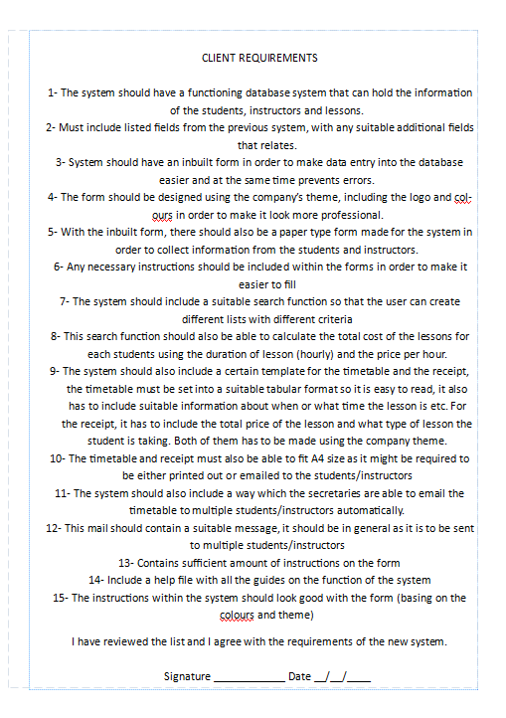

# 3.Design and planning for implementation

## 3.1.Draft Design Work

**Instructors Table**

|  |  |  |  |  |  |
| --- | --- | --- | --- | --- | --- |
| **Field Name** | **Data Type** | **Field Length** | **Input Mask/Format** | **Validation Rule** | **Validation Text** |
| InstructorsID (keyfield) | AutoNumber |  |  |  |  |
| InstructorsSurname | Short Text | 50 |  | Is Null Or Not Like "*[!a-z]*" Presence check | Please only enter letters from A-Z |
| InstructorsFirstName | Short Text | 30 |  | Is Null Or Not Like "*[!a-z]*"  Presence check | Please only enter letters from A-Z |
| Gender | Short Text | 6 | Dropdown List – Male or Female | Presence check | Please choose Male or Female |
| DOB | Date/Time |  | 00/00/0000;0;_ | Presence check |  |
| QatarID | Number |  | 00000000000 | Presence check |  |
| Address | Short Text | 100 |  | Presence check |  |
| POBox | Number |  | 00000 | Presence check |  |
| EmailAddress | Short Text | 40 |  | Is Null Or ((Like "*?@?*.?*") And (Not Like "*[ ,;]*"))  Presence check | Incorrect email format (Must include . or @) |
| ContactNumber | Short Text | 11 | +974 "00000000;;_ | Presence check |  |
| NextOfKinSurname | Short Text | 50 |  | Is Null Or Not Like "*[!a-z]*"  Presence check | Please only enter letters from A-Z |
| NextOfKinFirstName | Short Text | 30 |  | Is Null Or Not Like "*[!a-z]*"  Presence check | Please only enter letters from A-Z |
| NextOfKinContactNumber | Short Text | 11 | +974 "00000000;;_ | Presence check |  |

**Students Table**

|  |  |  |  |  |  |
| --- | --- | --- | --- | --- | --- |
| **Field Name** | **Data Type** | **Field Length** | **Input Mask/Format** | **Validation Rule** | **Validation Text** |
| StudentsID (keyfield) | AutoNumber |  |  |  | Field must not be left blank! |
| StudentsSurname | Short Text | 50 |  | Is Null Or Not Like "*[!a-z]*"  Presence check | Please only enter letters from A-Z  Field must not be left blank! |
| StudentsFirstName | Short Text | 30 |  | Is Null Or Not Like "*[!a-z]*"  Presence check | Please only enter letters from A-Z  Field must not be left blank! |
| Gender | Short Text | 6 | Dropdown List – Male or Female | Presence check | Please choose Male or Female  Field must not be left blank! |
| DOB | Date/Time |  | 00/00/0000;0;_ | Presence check | Field must not be left blank! |
| QatarID | Number |  | 00000000000 | Presence check | Field must not be left blank! |
| Address | Short Text | 100 |  | Presence check | Field must not be left blank! |
| POBox | Number |  | 00000 | Presence check | Field must not be left blank! |
| EmailAddress | Short Text | 40 |  | Is Null Or ((Like "*?@?*.?*") And (Not Like "*[ ,;]*"))  Presence check | Incorrect email format (Must include . or @)  Field must not be left blank! |
| ContactNumber | Short Text | 11 | +974 "00000000;;_ | Presence check | Field must not be left blank! |
| NextOfKinSurname | Short Text | 50 |  | Is Null Or Not Like "*[!a-z]*"  Presence check | Please only enter letters from A-Z  Field must not be left blank! |
| NextOfKinFirstName | Short Text | 30 |  | Is Null Or Not Like "*[!a-z]*"  Presence check | Please only enter letters from A-Z  Field must not be left blank! |
| NextOfKinContactNumber | Short Text | 11 | +974 "00000000;;_ | Presence check | Field must not be left blank! |

**Lessons Table**

|  |  |  |  |  |
| --- | --- | --- | --- | --- |
| **Field Name** | **Data Type** | **Input Mask/Format** | **Validation Rule** | **Validation Text** |
| LessonID (keyfield) | AutoNumber |  |  | Field must not be left blank! |
| StudentID | Number |  | Presence check | Field must not be left blank! |
| InstructorID | Number |  | Presence check | Field must not be left blank! |
| LessonTypeID | Number |  | Presence check | Field must not be left blank! |
| ScheduleID | Number |  | Presence check | Field must not be left blank! |
| StartTime | Date/Time | 00:00;0;_ | Presence check | Field must not be left blank! |
| EndTime | Date/Time | 00:00;0;_ | Presence check | Field must not be left blank! |
| Total Cost | Currency | #,##0.00" QAR";-#,##0.00"QAR" |  | Field must not be left blank! |

This certain field will be mainly used when the query for receipt has been created to calculate the total cost of the lessons for a certain student.

**LessonType Table**

|  |  |  |  |  |
| --- | --- | --- | --- | --- |
| **Field Name** | **Data Type** | **Input Mask** | **Validation Rule** | **Validation Text** |
| LessonTypeID (keyfield) | AutoNumber |  |  | Field must not be left blank! |
| LessonType | Short Text |  | Presence check | Field must not be left blank! |
| CostPerHour | Currency |  | Presence check | Field must not be left blank! |

**Schedule Table**

|  |  |  |  |  |
| --- | --- | --- | --- | --- |
| **Field Name** | **Data Type** | **Input Mask/Format** | **Validation Rule** | **Validation Text** |
| ScheduleID (keyfield) | AutoNumber |  |  | Field must not be left blank! |
| ScheduleDate | Date/Time | 99/99/0000;0;_ | Presence check | Field must not be left blank! |

**Times Table**

|  |  |  |  |  |
| --- | --- | --- | --- | --- |
| **Field Name** | **Data Type** | **Input Mask/Format** | **Validation Rule** | **Validation Text** |
| TimesID (keyfield) | AutoNumber |  |  | Field must not be left blank! |
| LessonTypeID | Number |  | Presence check | Field must not be left blank! |
| Time | Date/Time | 00:00;0;_ | Presence check | Field must not be left blank! |

**Table Relationship**

Schedule_tb

LessonType_tb

Students_tb

Lessons_tb

Times_tb1

Times_tb

Instructors_tb

This is the relationship of the tables. I have 2 copies of time tables because it links to 2 fields, start time and end time respectively. All the relationship shown on the diagram are one-to-many.

**Data Entry Form – Students and Instructors**

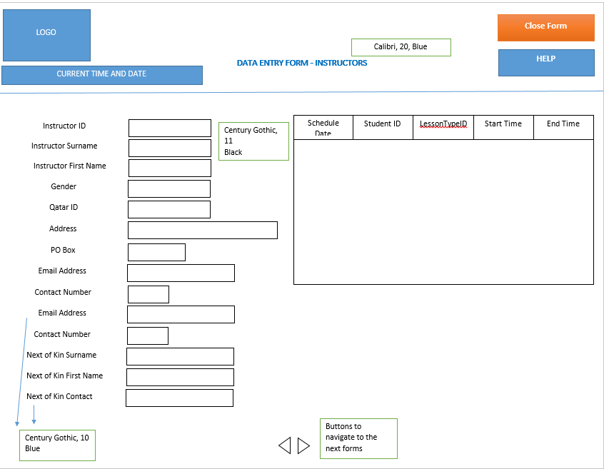

This is my proposed design for the student’s data entry form, I have included the company’s logo on the top corner. I have also included another form within it to show the lessons history of the instructor. I have also included buttons to get on to the next forms to make it look more professional.

**Data Entry Form – Students and Instructors**

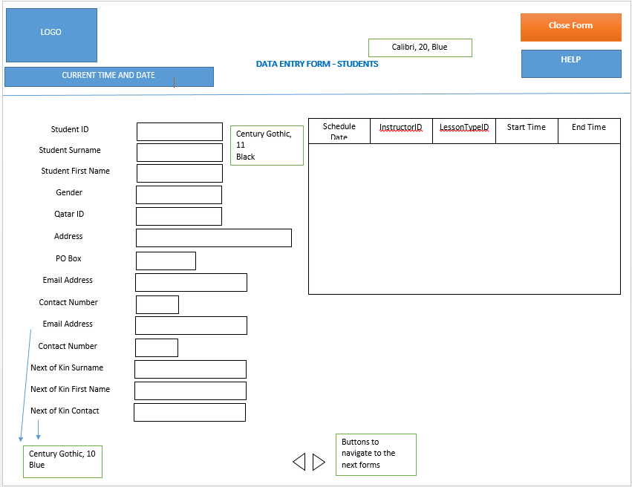

The student data entry form is identical to the instructor’s form. It contains all the features as stated above and I have included the student lesson history form within the original entry form itself which is displayed in a tabular form.

**Data Entry Form – Schedule and Booking Form**

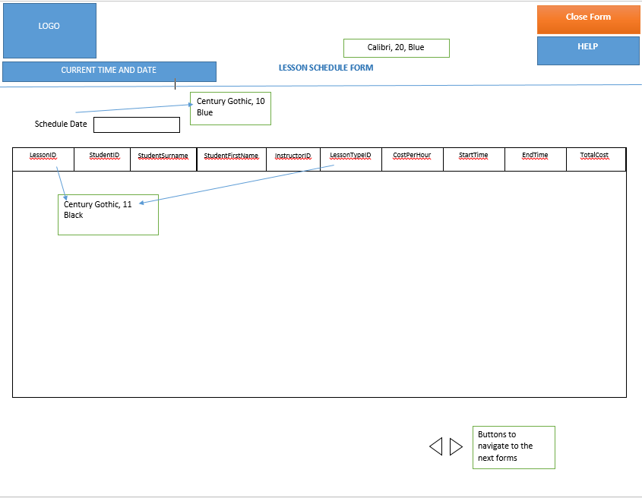

The schedule form will be where the user will start in order to create a booking, the schedule form shows all the lessons for the entered dates, and if the student has checked if the timings are available, the user can easily use the button to create the booking which will link to the form below.  
The sub form should be formatted in a tabular manner which is a suitable way to display the information.

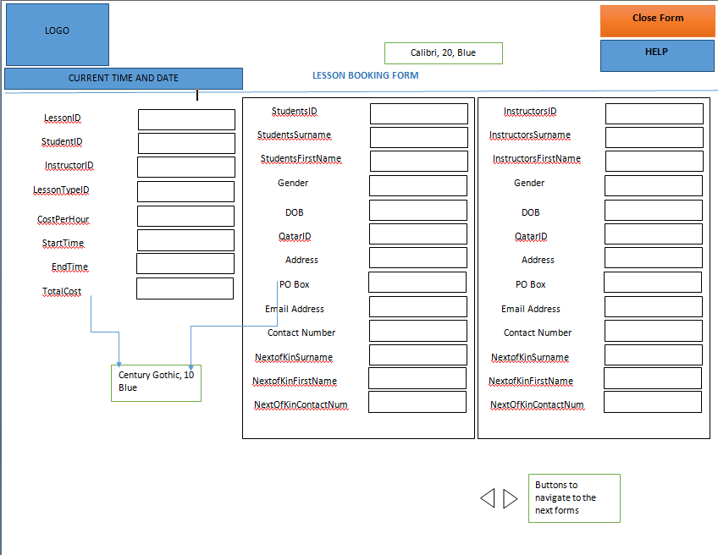

This is the booking form. The main form that will be used on the database. I have included 2 sub forms within the actual form in order to make it easier to check if the entered student and instructor ID were correct. This form will be linked to the schedule form via the button I have showed in the previous picture. The form is displayed in a columnar way to make the data easier to enter and read. The font sizes and colors will be almost identical to the previous form, using the trademark blue of the company’s logo.

**Data Capture Form**

Since Mr. Sheikh now requires Qatar ID for both the students and instructors, I have created a new data entry form with this field to be able to collect the new information.   
This is my initial design of the data capture form, I have purposely designed it to be similar to the data entry form which comes with the company’s colour theme. Again, the design is simple and easy to read – basically a normal form that most people would be able to fill in easily. I am planning to include several instructions on the form for the fields that requires to be entered in a certain format (e.g. email format). I have included boxes to enter the fields with digit like their Qatar ID number as almost like a length check for them.

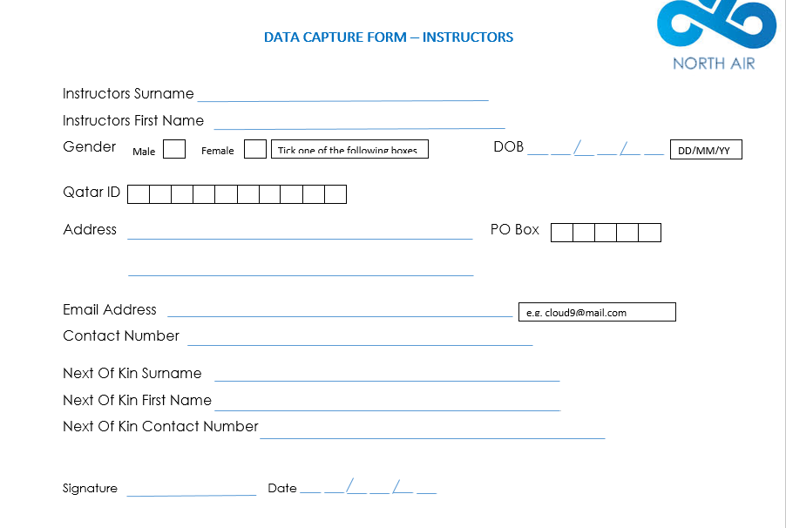

Font: Century Gothic  
Size: 14

Font: Calibri Light  
Size: 16  
Blue (similar to logo’s colour

*Instructions*

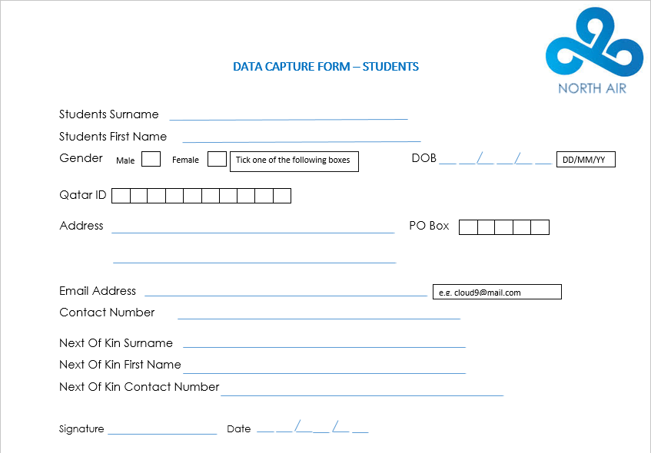

Font: Calibri Light  
Size: 16  
Blue (similar to logo’s colour

Font: Century Gothic  
Size: 14

**Query Design**

|  |  |  |  |  |  |  |
| --- | --- | --- | --- | --- | --- | --- |
| **Name of Query** | **Type of Query** | **Purpose of Query** | **Tables Queried** | **Fields Queried** | **Criteria** | **Fields Displayed** |
| Students Timetable Query | Wildcard | A list of lessons a certain student has registered with the school. Will be categorized by their surname and first name. | Students Table, Instructors Table, Lesson Table, Schedule Table, Lesson Type Table. | Students Surname, Students First Name | Like "*" & [Please enter Students Surname] & "*" Like "*" & [Please enter Students First Name] & "*" Like [Please enter Students ID] | Students surname, Students First Name, Students ID, Instructors First Name, Instructors Surname, Schedule Date, Start Time, End Time, Lesson Type |
| Instructors Timetable Query | Wildcard | A list of lessons a certain instructor has on the existing table. Will be categorized by their surname and first name. | Students Table, Instructors Table, Lesson Table, Schedule Table, Lesson Type Table. | Instructors Surname, Instructors First Name | Like [Please enter Instructors ID]  Like "*" & [Please enter Instructors Surname] & "*" Like "*" & [Please enter Instructors First Name] & "*" | Students surname, Students First Name, Students ID, Instructors First Name, Instructors Surname, Schedule Date, Start Time, End Time, Lesson Type |
| Lesson Type Query | Wildcard | A list of students registered for a certain type of lesson | Students Table, Lessons Table, Lesson Type Table. | Lesson Type | “Day”, “Peak Time”, “Night”   Like [Please enter Day, Peak Time or Night] | Students Surname, Students First Name, Students ID, Lesson Type, Start Time, End Time, Instructor ID |
| Receipt Query | Complex | To create a receipt for the students who has registered for a lesson | Lesson Type Table, Students Table, Lesson Table. | Cost Per Hour, Start Time, End Time, Students First Name, Students Surname | =(DateDiff("h",[EndTime],[StartTime])/-24)*[CostPerHour]  Like "*" & [Please enter Students Surname] & "*" Like "*" & [Please enter Students First Name] & "*" | Students Surname, Students First Name, Lesson Type, Cost Per Hour, “Total Cost”, Lesson ID |
| Student | Wildcard | To allow the user to find a certain student | Students Table | Students ID, First Name, Surname, DOB, Qatari ID | Like "*" & [Please enter Students Surname] & "*" (For all the fields listed on the side) | All fields |
| Instructors | Wildcard | To allow the user to find a certain instructor | Instructor | Instructor ID, First Name, Surname, DOB, Qatari ID | Like "*" & [Please enter Students Surname] & "*" (For all the fields listed on the side) | All fields |

**Report Design - Timetable**

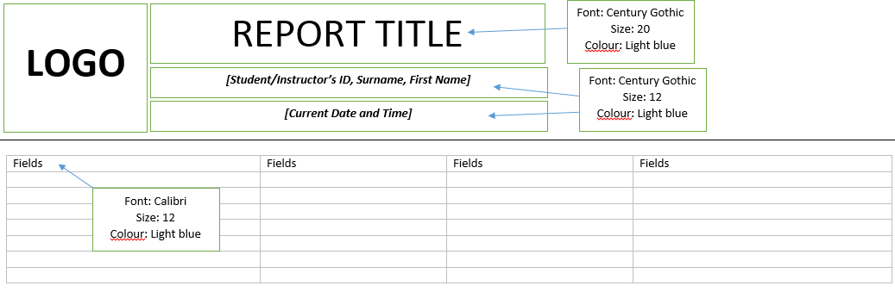

This is the basic design of my timetable, it will be a tabular view of the details of the lesson.  
This type of view is the most suitable for timetables, it is easy to read and the information are clearly laid out.

**Report Design – Receipt**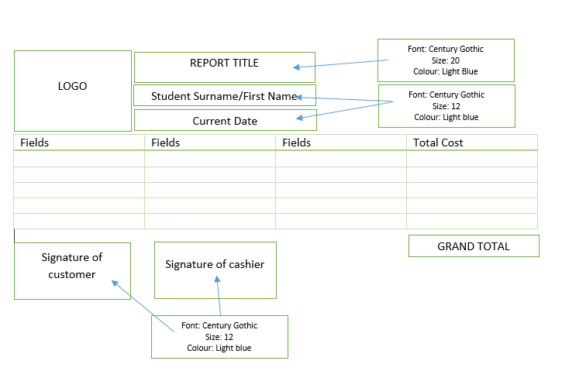

The basic design of my receipt will be similar to my timetable, the layout is simple and easy to read. At the bottom I have added boxes for the grand total receipt and the signature from both the cashier and the student.

## 3.2.Final Design Work

**Final Design – Table**

**Customer Feedback**I have showed Mr. Sheikh the design of the tables and he was fully satisfied with them. He felt that the addition of the validation text will certainly help his less experienced staff in adapting to the system, and the fact that I have included quite a lot of validation rule.

**Instructors Table**

|  |  |  |  |  |  |
| --- | --- | --- | --- | --- | --- |
| **Field Name** | **Data Type** | **Field Length** | **Input Mask/Format** | **Validation Rule** | **Validation Text** |
| InstructorsID (keyfield) | AutoNumber |  |  |  |  |
| InstructorsSurname | Short Text | 50 |  | Is Null Or Not Like "*[!a-z]*" Presence check | Please only enter letters from A-Z This field must not be left blank! |
| InstructorsFirstName | Short Text | 30 |  | Is Null Or Not Like "*[!a-z]*" Presence check | Please only enter letters from A-Z This field must not be left blank! |
| Gender | Short Text | 6 | Dropdown List – Male or Female | Presence check | Please choose Male or Female This field must not be left blank! |
| DOB | Date/Time |  | 00/00/0000;0;_ | Presence check | This field must not be left blank! |
| QatarID | Number |  | 00000000000 | Presence check | This field must not be left blank! |
| Address | Short Text | 100 |  | Presence check | This field must not be left blank! |
| POBox | Number |  | 00000 | Presence check | This field must not be left blank! |
| EmailAddress | Short Text | 40 |  | Is Null Or ((Like "*?@?*.?*") And (Not Like "*[ ,;]*")) Presence check | Incorrect email format (Must include . or @) This field must not be left blank! |
| ContactNumber | Short Text | 11 | +974 "00000000;;_ | Presence check | This field must not be left blank! |
| NextOfKinSurname | Short Text | 50 |  | Is Null Or Not Like "*[!a-z]*" Presence check | Please only enter letters from A-Z This field must not be left blank! |
| NextOfKinFirstName | Short Text | 30 |  | Is Null Or Not Like "*[!a-z]*" Presence check | Please only enter letters from A-Z This field must not be left blank! |
| NextOfKinContactNumber | Short Text | 11 | +974 "00000000;;_ | Presence check | This field must not be left blank! |

**Students Table**

|  |  |  |  |  |  |
| --- | --- | --- | --- | --- | --- |
| **Field Name** | **Data Type** | **Field Length** | **Input Mask/Format** | **Validation Rule** | **Validation Text** |
| StudentsID (keyfield) | AutoNumber |  |  |  |  |
| StudentsSurname | Short Text | 50 |  | Is Null Or Not Like "*[!a-z]*" Presence check | Please only enter letters from A-Z This field must not be left blank! |
| StudentsFirstName | Short Text | 30 |  | Is Null Or Not Like "*[!a-z]*" Presence check | Please only enter letters from A-Z This field must not be left blank! |
| Gender | Short Text | 6 | Dropdown List – Male or Female | Presence check | Please choose Male or Female This field must not be left blank! |
| DOB | Date/Time |  | 00/00/0000;0;_ | Presence check | This field must not be left blank! |
| QatarID | Number |  | 00000000000 | Presence check | This field must not be left blank! |
| Address | Short Text | 100 |  | Presence check | This field must not be left blank! |
| POBox | Number |  | 00000 | Presence check | This field must not be left blank! |
| EmailAddress | Short Text | 40 |  | Is Null Or ((Like "*?@?*.?*") And (Not Like "*[ ,;]*")) Presence check | Incorrect email format (Must include . or @) This field must not be left blank! |
| ContactNumber | Short Text | 11 | +974 "00000000;;_ | Presence check | This field must not be left blank! |
| NextOfKinSurname | Short Text | 50 |  | Is Null Or Not Like "*[!a-z]*" Presence check | Please only enter letters from A-Z This field must not be left blank! |
| NextOfKinFirstName | Short Text | 30 |  | Is Null Or Not Like "*[!a-z]*" Presence check | Please only enter letters from A-Z This field must not be left blank! |
| NextOfKinContactNumber | Short Text | 11 | +974 "00000000;;_ | Presence check | This field must not be left blank! |

**Lessons Table**

|  |  |  |  |  |
| --- | --- | --- | --- | --- |
| **Field Name** | **Data Type** | **Input Mask/Format** | **Validation Rule** | **Validation Text** |
| LessonID (keyfield) | AutoNumber |  |  |  |
| StudentID | Number |  | Presence check | This field must not be left blank! |
| InstructorID | Number |  | Presence check | This field must not be left blank! |
| LessonTypeID | Number |  | Presence check | This field must not be left blank! |
| ScheduleID | Number |  | Presence check | This field must not be left blank! |
| hStartTime | Date/Time | 00:00;0;_ | Presence check | This field must not be left blank! |
| EndTime | Date/Time | 00:00;0;_ | Presence check | This field must not be left blank! |
| Total Cost | Currency | #,##0.00" QAR";-#,##0.00"QAR" |  | This field must not be left blank! |

**LessonType Table**

|  |  |  |  |  |
| --- | --- | --- | --- | --- |
| **Field Name** | **Data Type** | **Input Mask** | **Validation Rule** | **Validation Text** |
| LessonTypeID (keyfield) | AutoNumber |  |  |  |
| LessonType | Short Text |  | Presence check | This field must not be left blank! |
| CostPerHour | Currency |  | Presence check | This field must not be left blank! |

**Schedule Table**

|  |  |  |  |  |
| --- | --- | --- | --- | --- |
| **Field Name** | **Data Type** | **Input Mask/Format** | **Validation Rule** | **Validation Text** |
| ScheduleID (keyfield) | AutoNumber |  |  |  |
| ScheduleDate | Date/Time | 99/99/0000;0;_ | Presence check | This field must not be left blank! |

**Times Table**

|  |  |  |  |  |
| --- | --- | --- | --- | --- |
| **Field Name** | **Data Type** | **Input Mask/Format** | **Validation Rule** | **Validation Text** |
| TimesID (keyfield) | AutoNumber |  |  |  |
| LessonTypeID | Number |  | Presence check | This field must not be left blank! |
| Time | Date/Time | 00:00;0;_ | Presence check | This field must not be left blank! |

**Final Design – Query**Mr. Sheikh is satisfied with the amount of available queries and he is happy on the function of each every one of them

|  |  |  |  |  |  |  |
| --- | --- | --- | --- | --- | --- | --- |
| **Name of Query** | **Type of Query** | **Purpose of Query** | **Tables Queried** | **Fields Queried** | **Criteria** | **Fields Displayed** |
| Students Timetable Query | Wildcard | A list of lessons a certain student has registered with the school. Will be categorized by their surname and first name. | Students Table, Instructors Table, Lesson Table, Schedule Table, Lesson Type Table. | Students Surname, Students First Name | Like "*" & [Please enter Students Surname] & "*" Like "*" & [Please enter Students First Name] & "*" Like [Please enter Students ID] | Students surname, Students First Name, Students ID, Instructors First Name, Instructors Surname, Schedule Date, Start Time, End Time, Lesson Type |
| Instructors Timetable Query | Wildcard | A list of lessons a certain instructor has on the existing table. Will be categorized by their surname and first name. | Students Table, Instructors Table, Lesson Table, Schedule Table, Lesson Type Table. | Instructors Surname, Instructors First Name | Like [Please enter Instructors ID]  Like "*" & [Please enter Instructors Surname] & "*" Like "*" & [Please enter Instructors First Name] & "*" | Students surname, Students First Name, Students ID, Instructors First Name, Instructors Surname, Schedule Date, Start Time, End Time, Lesson Type |
| Lesson Type Query | Wildcard | A list of students registered for a certain type of lesson | Students Table, Lessons Table, Lesson Type Table. | Lesson Type | “Day”, “Peak Time”, “Night”   Like [Please enter Day, Peak Time or Night] | Students Surname, Students First Name, Students ID, Lesson Type, Start Time, End Time, Instructor ID |
| Receipt Query | Complex | To create a receipt for the students who has registered for a lesson | Lesson Type Table, Students Table, Lesson Table. | Cost Per Hour, Start Time, End Time, Students First Name, Students Surname | =(DateDiff("h",[EndTime],[StartTime])/-24)*[CostPerHour]  Like "*" & [Please enter Students Surname] & "*" Like "*" & [Please enter Students First Name] & "*" | Students Surname, Students First Name, Lesson Type, Cost Per Hour, “Total Cost”, Lesson ID |
| Student | Wildcard | To allow the user to find a certain student | Students Table | Students ID, First Name, Surname, DOB, Qatari ID | Like "*" & [Please enter Students Surname] & "*" (For all the fields listed on the side) | All fields |
| Instructors | Wildcard | To allow the user to find a certain instructor | Instructor | Instructor ID, First Name, Surname, DOB, Qatari ID | Like "*" & [Please enter Students Surname] & "*" (For all the fields listed on the side) | All fields |

**Final Design – Data Entry Form  
Customer Feedback**I have showed Mr. Sheikh my initial draft design of the form, he was fairly satisfied with the format and the layout of the form. Despite this, he also said that the background was too plain and he would like it light blue, and for the font he’d prefer it to be Calibri instead of Century Gothic. He also suggested that I give the address a bigger box that’s aligned to the rest of the fields.   
*Below are the changes I have done to accommodate his needs:*   
**- Changed the colour of the background to blue  
- Change font on all the forms and reports to Calibri  
- Aligned the boxes**

This is my data entry form final design for both the students and instructors (identical design), as I’ve previously stated there are a few changes from the initial design, this one is the updated version with the things that Mr. Sheikh has requested applied on it.

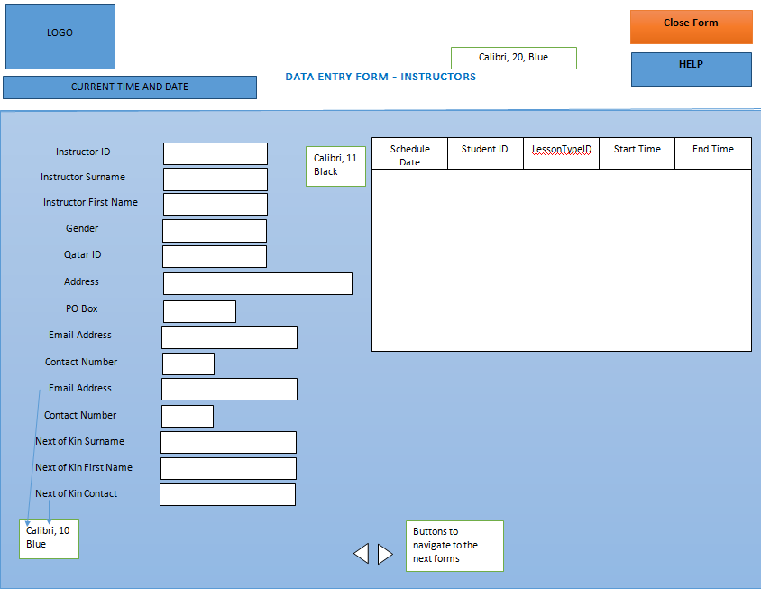

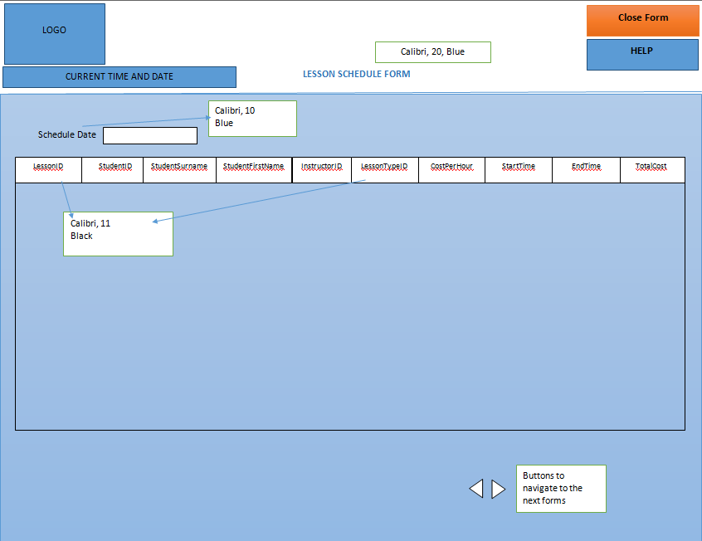

These two are the main forms that will be used by the user to create the bookings. They are connected with each other by the “make booking” button. The design has been adjusted from the request from Mr. Sheikh.   
The way that these two works is that the person will choose which date he wants to book, and then the table will show the person a list of lessons that are happening on that day. If the timing the person wants is available then the person should simply press the make booking button which will connect you into the booking form. In the booking form is where you enter your details. It is all coded where you enter an instructor ID, the detail of the instructor will show up on the table on the right hand side, which is a very helpful thing for the user.   
The buttons on the forms are to close, navigate into next records, to save and to start a new record. The help button will show a brief little help message which is linked to a macro I have created.

**Make Booking**

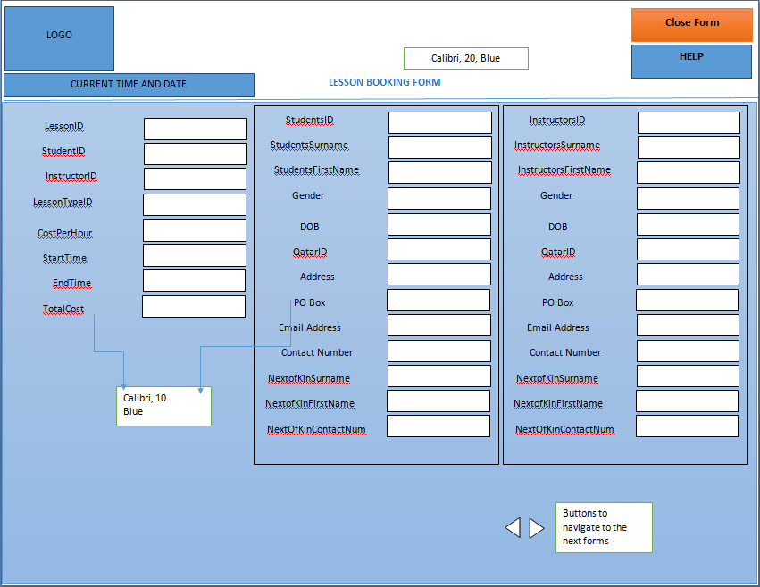

Save Record and New Booking buttons

**Final Design – Report (Timetable and Receipt)  
Customer Feedback**I have showed my initial design of how the timetable and receipt should look like to Mr. Sheikh. He has requested for me to add more colours into it just like the previous designs, he wants to add a blue themed colour that matches with the logo. He also wanted the font to all be switched to Calibri so that it matches with the other forms.  
**- Changed background colour to a blue/white theme  
- Font changed to Calibri (titles and names)**

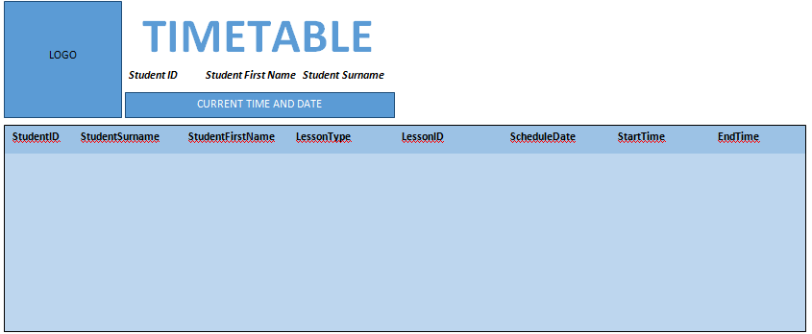

This is my final design of the timetable, it has significantly improved in terms of design as I initially started with a simpler classic white and green timetable. With the changes Mr. Sheikh has requested the new timetable looks more fitting for the company. The design of the timetable for the instructor is identical to this one, it would be better that way as they will seem more united as one company with the same theme for everyone to be able to enhance their identity as a school.

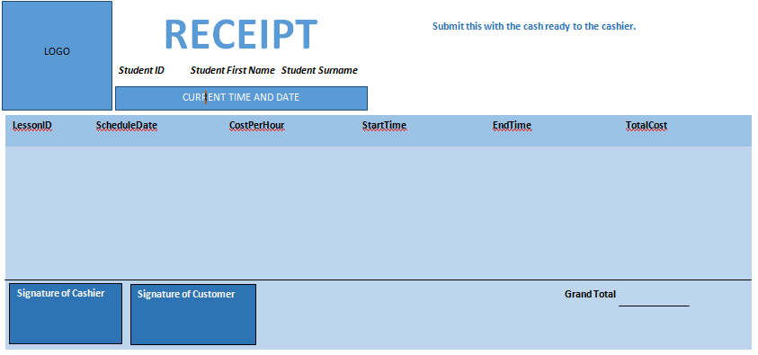

This is the final design of the receipt, as you can see it has all the changes Mr. Sheikh has asked for. The design now looks more professional and matches with all the previous forms I have created. The fonts are now all Calibri instead of Century Gothic as stated earlier.

Below is a sheet confirming that Mr. Sheikh has checked and reviewed all the designs from the tables, data entry and capture form, the timetable and the receipt.

**I, Mr. Sheikh have reviewed all the design work done by Dido and is satisfied with the final design he has done.**

*Date*

*Signature*

## 3.3.Plan for Implementation, Testing and Instalment, Including Proposed Time Scales

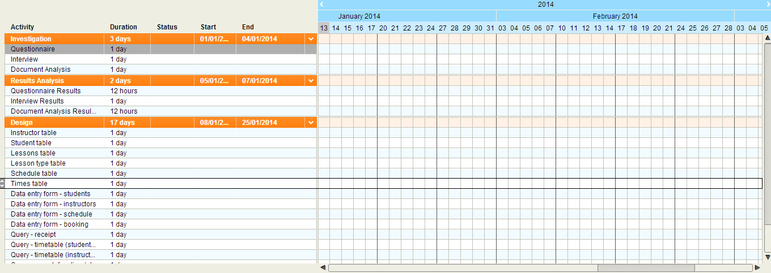

ANALYSIS AND DESIGN

IMPLEMENTATION

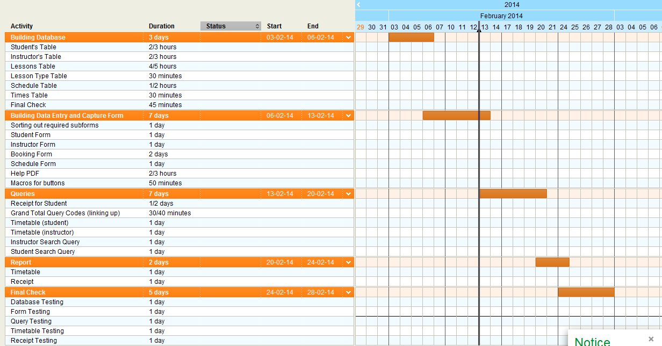

This is an initial proposal of my plan. The whole project will take around 2/3 weeks to finish including final checking if all the rules entered within the form are all valid. The times on the chart are very flexible; I have given myself more than enough time in order to be able to create a flawless effective system for my user. It is important that enough time is given for not only the whole making of it, but spending enough time checking whether it works in different scenarios.

## 3.4.Training Requirements of The New System

In order for the system to be used to its full potential the clients and end users will need to be trained suitably to be ready for the system. I have decided to give my end user, Mr. Miller basic access video tutorials on how to basically use. I will also give him a private tutoring on how to create a timetable and receipt. My presence will help him so that he can freely ask me any questions he wants regarding the system

**Help Document (PDF document)**This will be a document with all the FAQs and instructions regarding the system. It will contain details on what the buttons does, how it works, step by step instructions on how to create a timetable, a receipt, entering a new record etc.   
At the bottom of the page I have created a series of frequently asked questions with answers which might be a quick help for the user.

1. How to create a timetable

2. How to create a receipt

3. How to use the queries

4. How to delete an existing record

5. How to add a new record

## 3.5.Testing strategy

The purpose of having a strategy of testing is to check whether the system works as its supposed to be and to ensure that no errors are made throughout the entire process. There are different types of testing that I will have to do to make sure that this system works perfectly as intended. I will give the system a time of 3 weeks for the testing period when it runs in the school, it will be a user testing where the user will carry on business as usual, but at the same time I will still monitor how the system is coping. Basically I will be observing the beta of the system to see whether it is ready for full launch. The beta system will have all the features the other system has but it will still be considered initial beta as it is still within the testing process.   
I will also carry out an initial test before this called modular testing. This is where I check whether all the functions on my system works as intended. These are things like the receipt, whether the grand total calculates the right amount of money for the user, whether the database validation rule are intact – it is those small important functions of the system that will be thoroughly checked and tested.

## 3.6.Test Plan

|  |  |  |  |  |
| --- | --- | --- | --- | --- |
| Test No. | Name of test | Purpose of test | Test Data | Expected outcome |
| 1 | Email Validation Test | In order to see whether the validation rules applied for the emails are working as intended. This is found on the Student’s Entry Form. | Entering an email without @ or .  Basically an invalid format of an email | The validation text to pop up and remind the user that @ and . is required in an email. |
| 2 | Name Validation Test | To see whether the validation rule for the names works. This validation rule applies for all the name fields in the system. In this case I will be testing it on the Student’s Entry Form. | Entering a name with digits in them.  Entering a new First Name ‘Joe’ with a number 0 instead of letter O. | Validation text to pop up reminding the user that the names has to only contain alphabet. |
| 3 | Date of Birth Validation Test | To see whether the system accepts a birth date under 18. It applies for all the DOB fields in the system. In this case I will be testing the Student’s Entry Form. | Entering 09/06/1999 as a birthdate on the form. | The system should reject this data and a validation text saying ‘Age entered under 18’ should pop up. |
| 4 | Length Check | To see whether the fields with length check set on them accepts the right amount of numbers and that extra numbers aren’t allowed. This applies for the Contact Number, Qatar ID and Post Code field. In this case I will be testing the Student’s Entry Form. | Trying to enter a 4 digits post code. E.g. 1234 | An error should show requesting that you need to enter 5 digits. |
| 5 | Presence check test | To see whether the database accepts a blank field for any of the fields that has ‘Field Required’ as a yes. This applies for most of the fields on the Student’s Entry Form. | Leaving the first name and the surname of the student empty whilst entering a data in the data entry form. | A text to pop up saying that the field cannot be empty. |
| 6 | Dropdown Box Test | To see whether the dropdown box list are limited and user should not be allowed to enter a custom data. This applies for all of the dropdown box fields in the system except for the Student ID, Instructors ID and Lesson ID. In this case I will be testing the ‘Gender’ field in the Student’s Entry Form. | Entering a number after the Male or Female field, e.g. “Male1”. | The system should state that this isn’t in the list and should not naturally allow it to be added into the field. |
| 7 | Sub Form Test | To see whether the sub forms included in the forms include the relevant and correct information. This applies for all of the forms that has sub forms in them. In this case I will be testing the Lesson Booking Form. | Entering an invalid student number ‘20’. | The system should not show anything for this stated number as the ID doesn’t exist in the system. |
| 8 | Receipt Total Price Test | To see whether the ‘Total Price’ field and the ‘Grand Total’ gives you the right cost. In this case I will be testing Student #1, Alex Welbeck | Adjusting the data on the LessonType table, in this case changing the ‘Day Time’ price to 500 QAR from 650 QAR. | The Total Cost for his lesson on the 11th October should be now 1000 QAR instead of 1300 QAR.  The grand total should also be reduced by 300 QAR overall. |
| 9 | Booking A Lesson Test | To see whether a lesson can be booked properly on the system as it’s supposed to. | Creating a new record using a new student ‘Muhammad Sheikh’ on an available lesson slot. | For Student #13’s lesson to be registered on the Lesson Table. |
| 10 | Search Function Test: Receipt | To see whether the query gives me the correct data in order to create a receipt for the students. | Searching a student with ID #1, in this case its ‘Alex Welbeck’ | For the system to show me all 3 lessons of Student #1, lesson ID 1,3 and 4 respectively. This search function should also show the total price for each of the lessons for him. |
| 11 | Search Function Test: Timetable | To see whether the system gives me the right information for the timetable. This applies for both the Instructors and Students. | Searching student with Id #4, which is Owen Miller | For the system to show me that Owen is registered to 1 lesson with Lesson ID 10. This search function should also give me his lesson start and end time. |
| 12 | Search Function Test: Lesson Types | To see whether the function gives me the correct lessons that are registered to that respective lesson type. | Searching for students who are registered for a ‘Night’ lesson. | The system to show me that there are 4 students, with ID #1, #2, #3, and #4 registered to night lessons. |
| 13 | Macro/Buttons Check Test | To test whether each of the macros are working properly as the buttons that they are set on is clicked. This will also cover the testing for all the buttons I have created on the forms to show whether it works as it should.  This applies on all of the forms but I will be testing the Student’s Form. | Clicking the help button to see whether it shows the pop-up help message and by using the ‘Delete’ and ‘Save Record’ buttons. | The pop up message to pop up and the delete and save buttons to do its job respectively. |
| 14 | Dates Format Test | To test whether the dates format are correct and can are entered in MM/DD/YYYY. To also check whether they accept an illegal data for the date. This applies for all the forms with dates on them, in this case I will be testing the Student’s Form. | Entering 09/35/1992 as the birth date for a student. | A message to pop up that it is invalid. |

# 4.Testing documentation of the implementation

## 4.1.Evidence of Testing

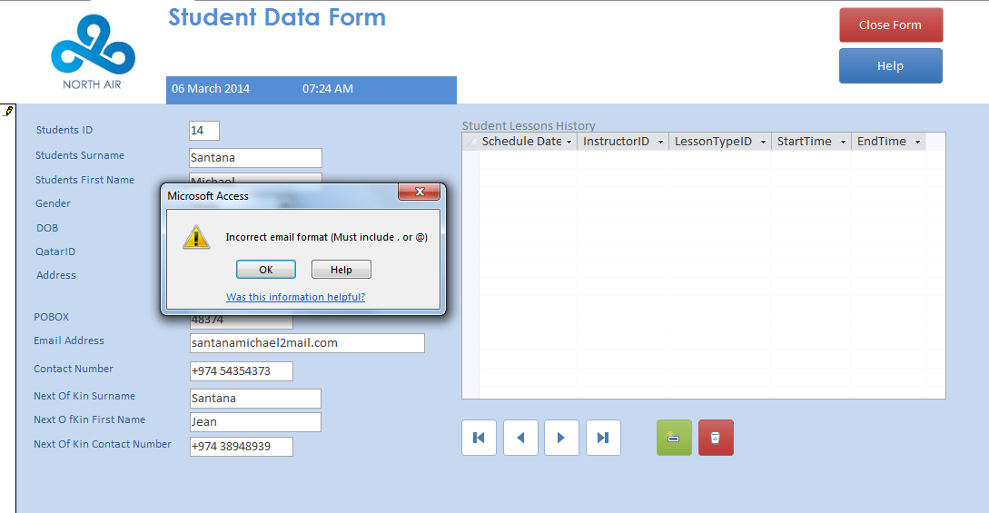**Email validation test**

Here is an example of the validation rule for the email address working in place. The text pops up when an invalid email is entered.

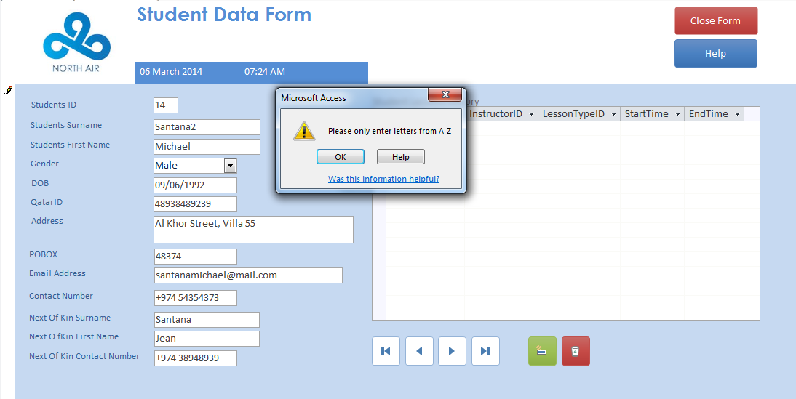**Name validation test**

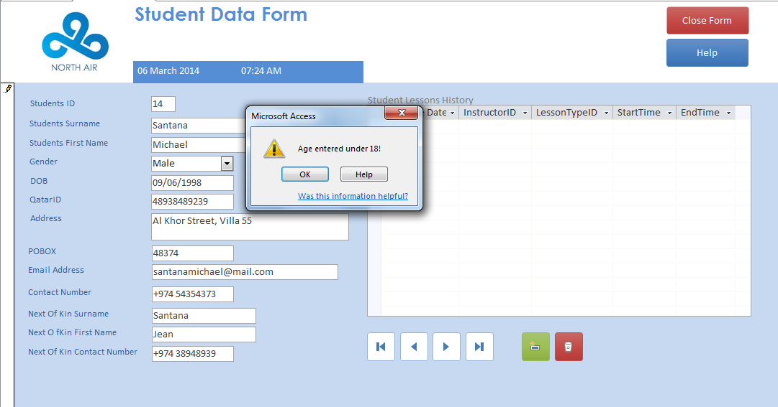  
**Date of birth validation test**

Here is an example of how the validation test for the text is placed. When entering a digit into the Student Surname field, the validation text pops up saying that you should only enter letters from A-Z.

This shows the validation rule for student under 18 working in place, in this case I have entered a birthdate of 09/06/1998, which is under 18 that is not allowed to be registered for lessons.

**Length check test**

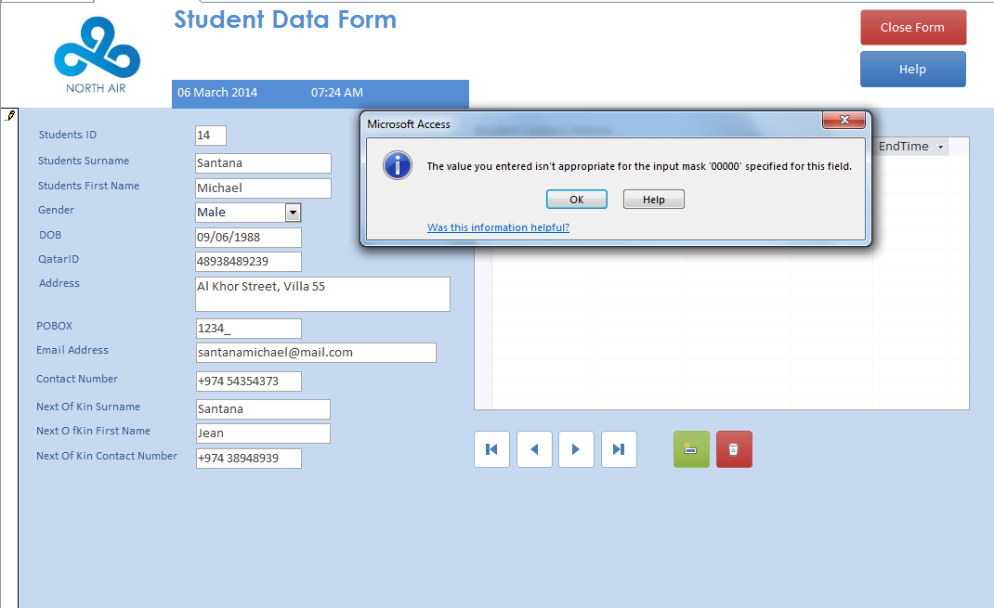

This shows the length check put into place, the PO Box field doesn’t allow only 4 digits as its PO Box as its set as 5.

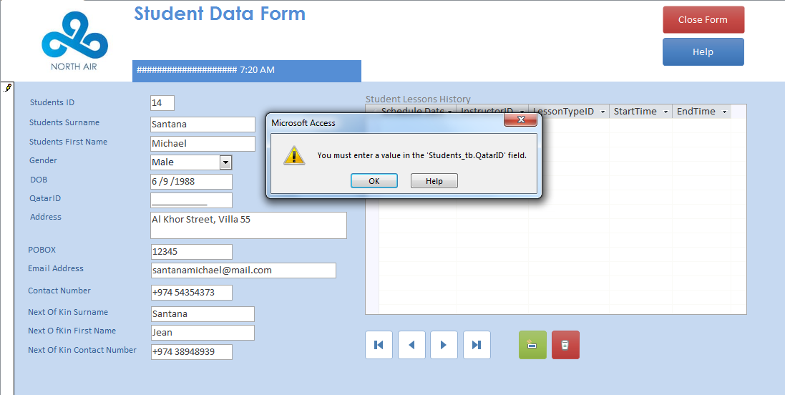**Presence check test**

This shows the presence check put in place for the QatarID field, it shows how you cannot save the record/proceed without having the field filled in.  
This also applies for the Student Surname, Student First Name, DOB, Email Address etc.

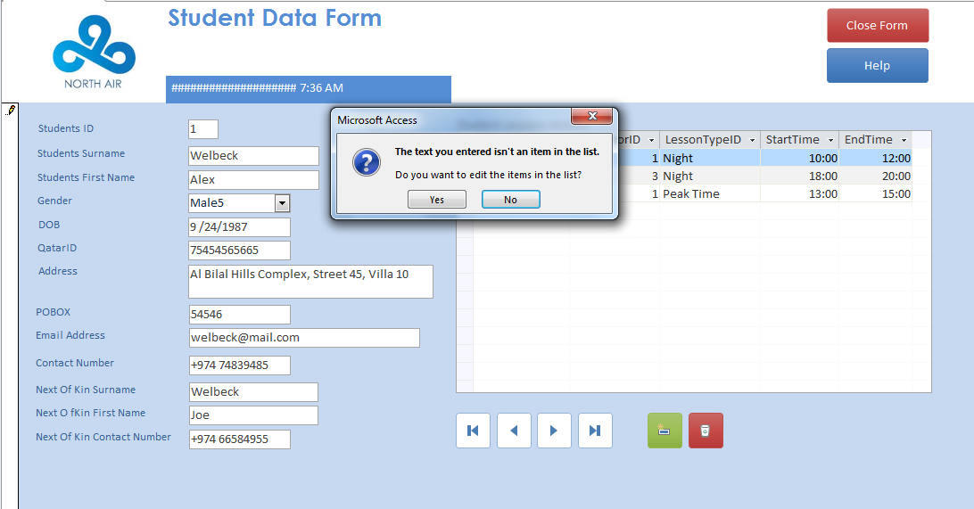**Dropdown box test**

**Sub form test**

This shows the presence check put in place for the QatarID field, it shows how you cannot save the record/proceed without having the field filled in.  
This also applies for the Student Surname, Student First Name, DOB, Email Address etc.

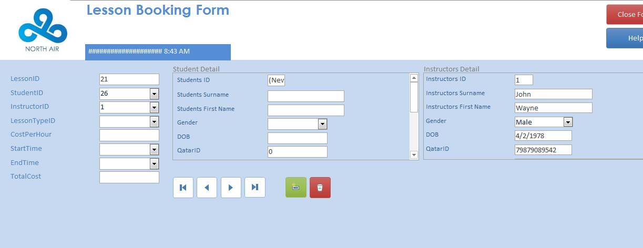

This shows how after I entered Student ID 26 on the form, the Student Detail sub form doesn’t give out anything as the student number doesn’t exist on the table. Whilst for the Instructor ID I have entered a valid ID and it has correctly given me the details of the Instructor with that ID.

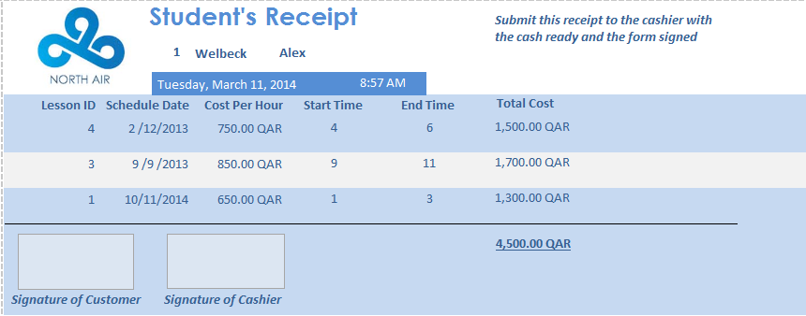**Receipt total price test**

This shows his usual receipt prior to the changes to the price per hour for Daytime (650 QAR)

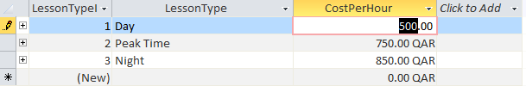

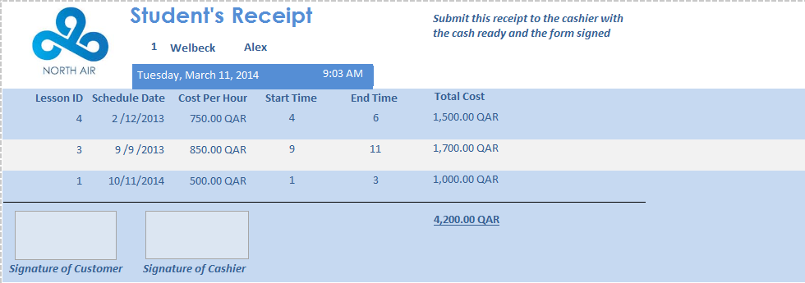

After changing the price for Day to 500 QAR, the receipt has changed accordingly as expected. The total cost for the 11th October lesson has reduced from 1300 to 1000 and the grand total has also reduced from 4500 to 4200. This shows that the formulas set on the costs are set out correctly.

**Booking a lesson test**

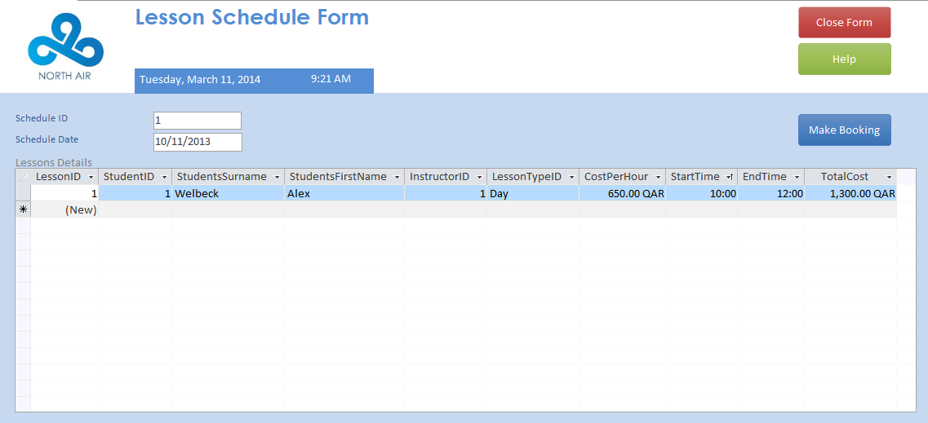

This is the schedule form showing the lessons listed on that certain day, if the dates are suitable then the person will click on the Make Booking button and go to the form shown next.

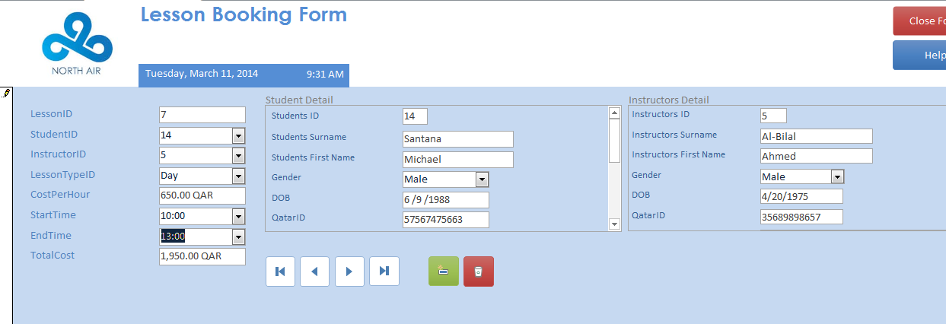

This is the lesson booking form, I have filled in the form with a new student’s details I previously added in (ID 14) it includes all the details such as the start time, which instructors he wants to use etc. After the details is filled in, there’s an ‘Add Record’ button which allows you to save the record.

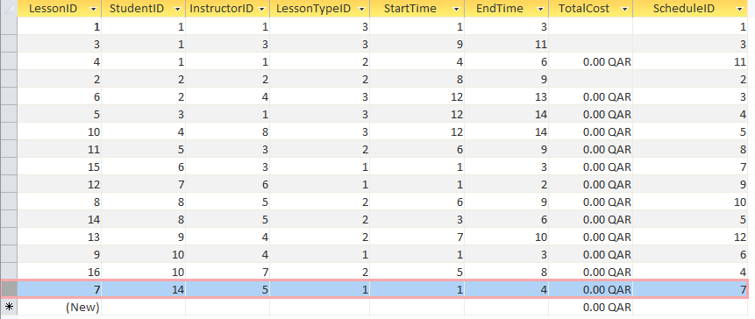

The picture above shows the new lesson added in onto a table as ‘Lesson ID 7’.

**Search function test: Timetable**

**As this test has a report attached to it, I will be testing the report function which automatically shows that the search query function is working properly.  
This procedure is also carried out when creating the timetable for the instructors’ as well.**

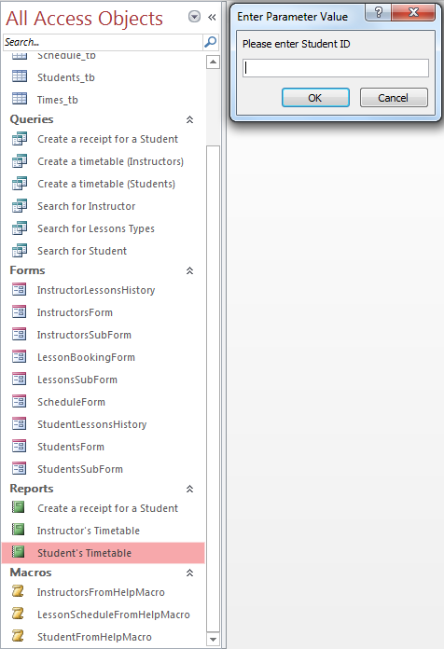

By clicking on the ‘Student’s Timetable’ query it will give you a parameter box value which will ask you details regarding the student you want. In this case as previously said not all of the boxes have to be filled in, one is enough to show you the details of the student if relevant. E.g. You know the student has the ID 7 or you know his last name is ‘Rodriguez’, you can ignore the other parameter values if you are certain.

In this case I will be entering student ID 1 which will give me a list of lessons Alex Welbeck has.

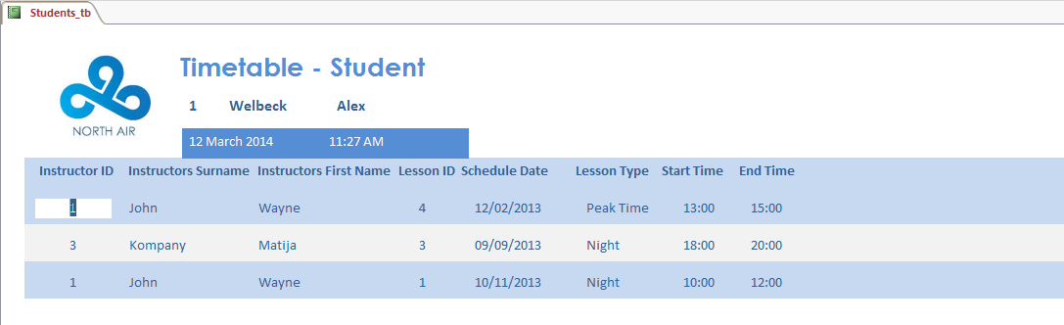

After entering Student ID 1, the search function has given me all the lessons that Alex Welbeck has booked. This automatically tells me that both the Report function and the Query search function are working as it should.

**Search function test: Receipt**

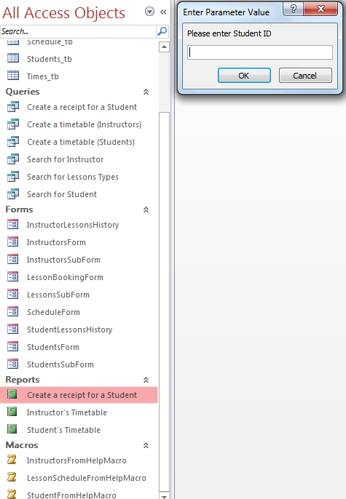

By clicking on the ‘Create a receipt for a Student’ report function, it will give you the same parameter box values as when you are creating a timetable. Again you can only fill in 1 box that you know of and ignore the rest.   
In this case I will again use Student ID 1, Alex Welbeck to create his receipt.

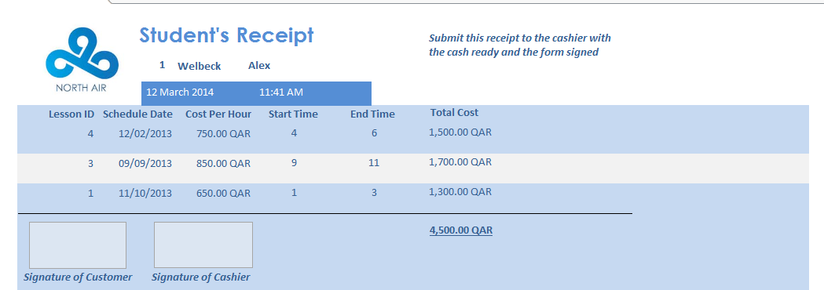

This shows the student receipt for Alex Welbeck, giving me his 3 lessons listed on the table aswell.

**Search function test: Lesson types**

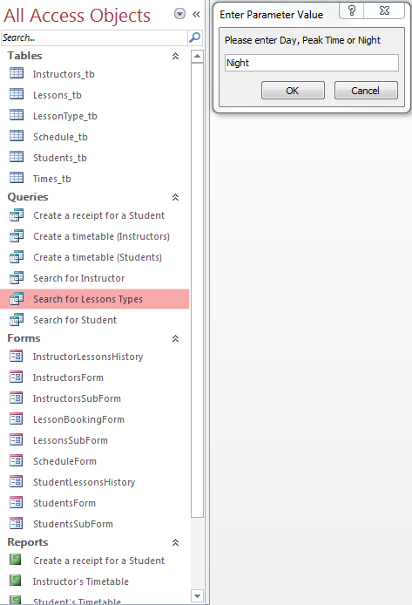

By clicking on the ‘Search for Lesson Types’ query, it will pop up a specific parameter value box asking to enter Day, Peak Time or Night which are the 3 lesson types with varying prices available at the flight school. The point of the search function is just to see who will be at a lesson in the morning, midday or night time.   
In this case I will be entering ‘Night’ as can be seen on the picture.

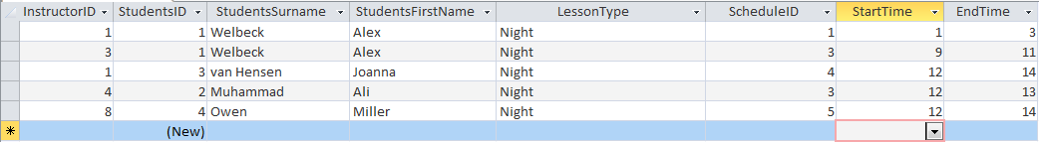

This shows the list that has been generated from the query, the students who has registered for a night lesson which shows that the search function is working as it should be.

**Macro/Buttons Test  
The buttons are on all of the forms so I will be testing 3 forms; Schedule Form, Booking Form and Student’s Form (identical to instructor)**

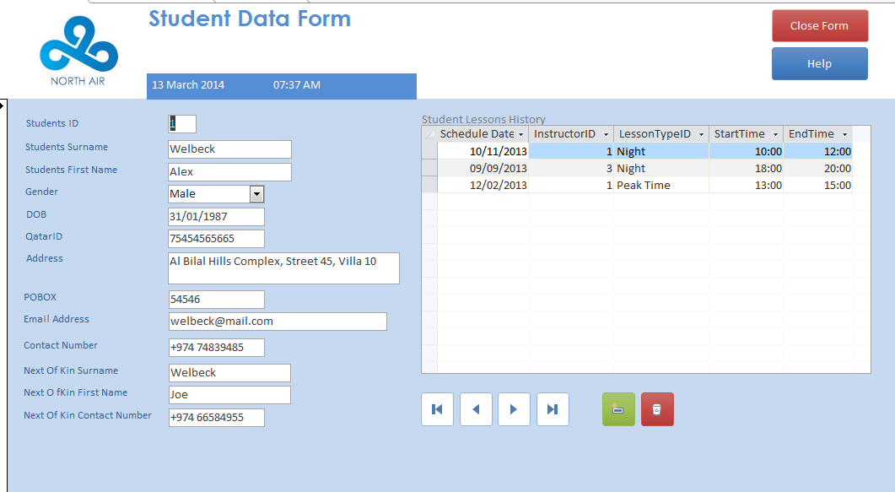

I will be testing whether the buttons created to see the next and previous record works as it should be.

This help button is linked to a macro set on the database system and will show a certain message for different forms.

The Delete Record button, used to delete any unwanted records.

The Add Record button will be important to the system when adding data.

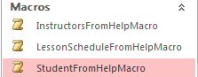

These are the macros set out for the 3 forms, as usual the Student and Instructors macro pops up the same message so I will only be testing the StudentHelp macro.   
All these 3 macros are set out on the ‘Help’ button on their respective forms.

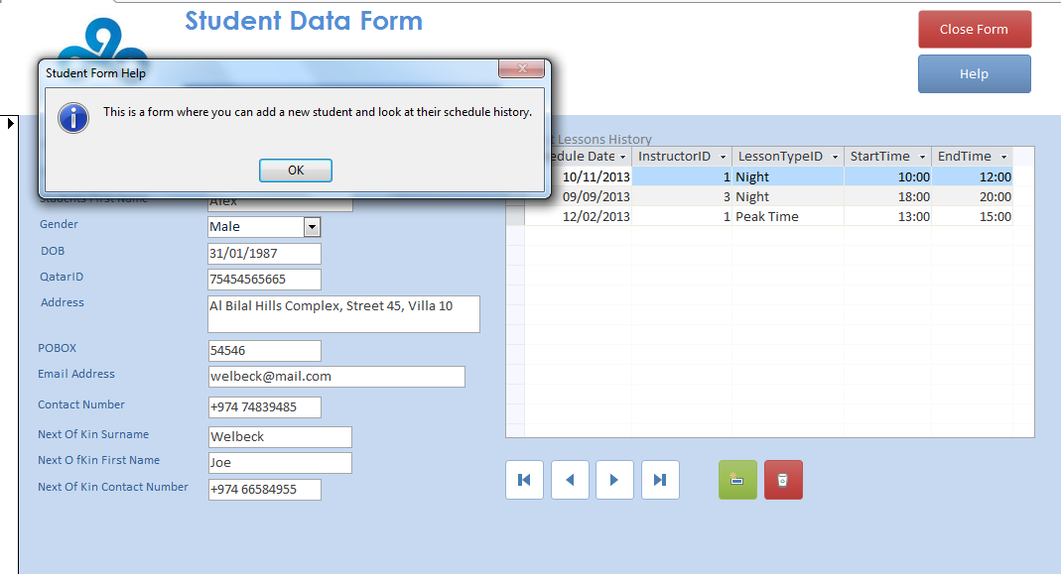

This shows the message that comes up when I click the help button. This message is set on the StudentFromHelpMacro which pops up whenever the user clicks on the help button.

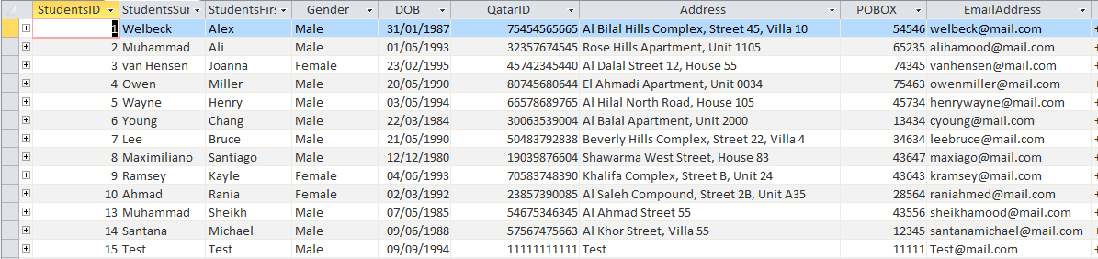

This table above is a modified table with a test student on it. As you can see Student 15 is the test student. I will open the following student’s details on the Student Data Form and delete it using the button provided.

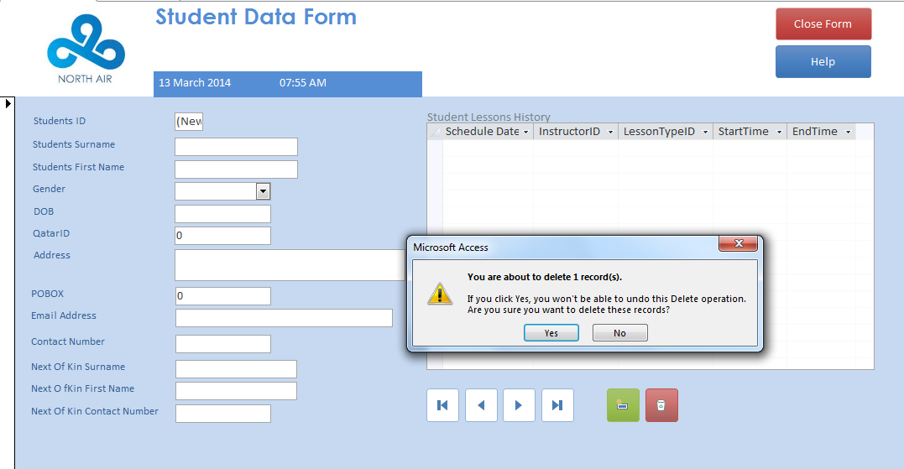

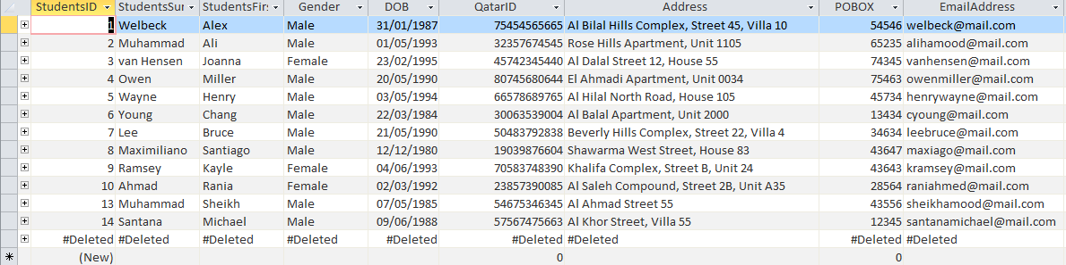

This image above shows the data form of that Student 15 about to be deleted using the button circled above.

After pressing yes, I checked the table and student 15 is deleted. This shows that the button works as it’s supposed to be.

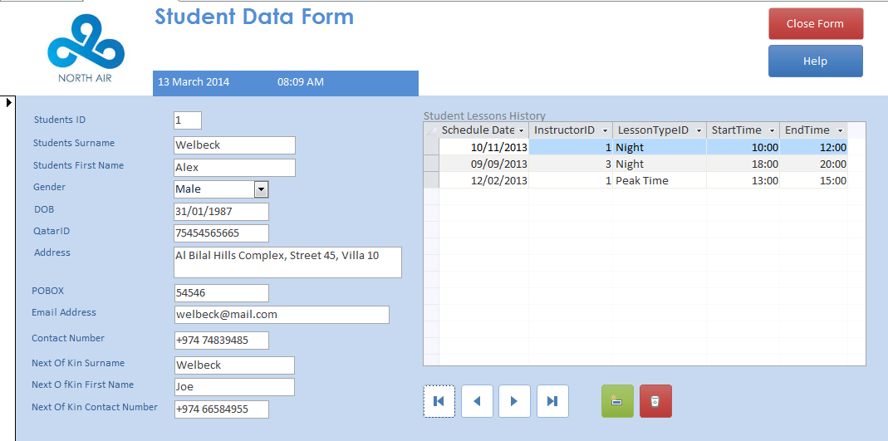

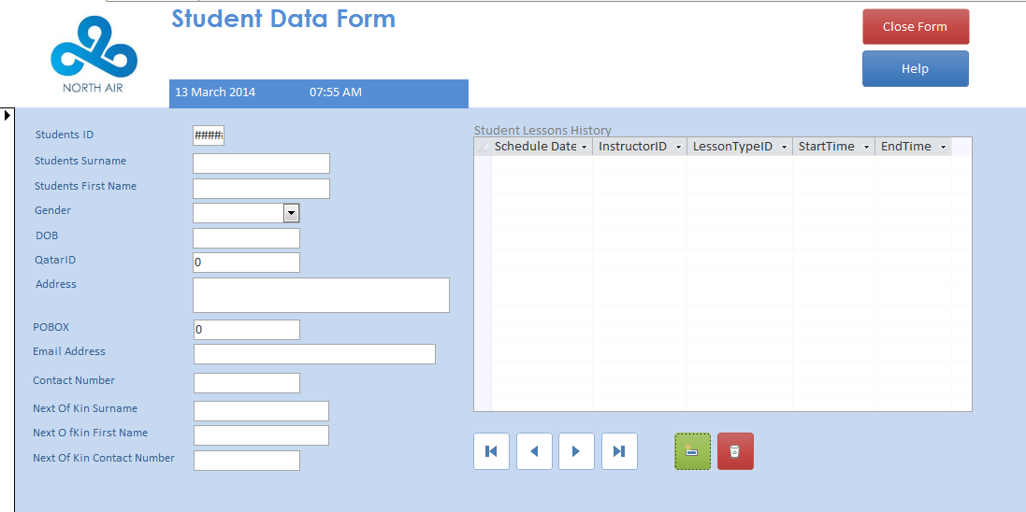

The empty form above shows that the ‘Add Record’ button works.   
The first picture shows how the form initially comes up, showing me Student 1 of the database. The second form is the empty form it links you to after pressing the ‘Add Record’ button.



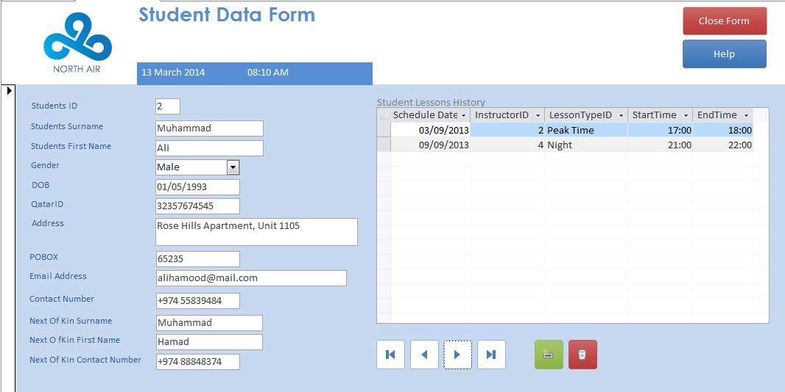

This shows that the buttons to navigate around to get the next and previous forms works. Above is a picture showing what happens when you press the next button, it links you to the next student. As you can see it is obviously student number 2, and this just shows that the button works properly.

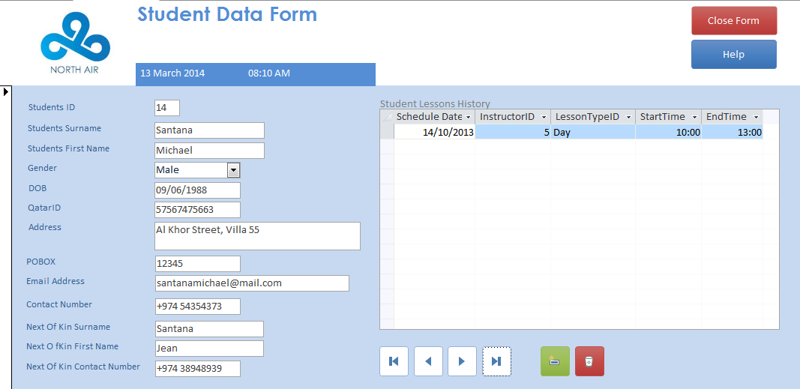

After that, I continued by testing the button that links you to the last form, As you can see it is student 14 in this case which again shows that the button is working as it’s supposed to.

**Dates Format Test**

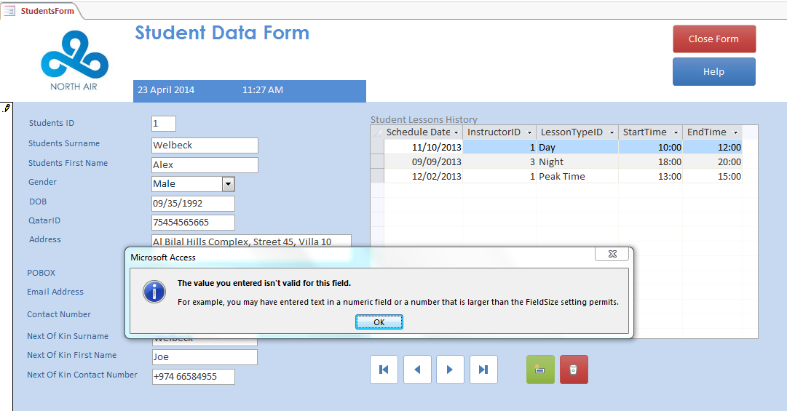

This above shows how the date format is properly set pm dd/mm/yyyy, where on the month part I have typed an invalid number and the database denied the numbers entered. This shows us that the set rule is working and the test is successful.

## 4.2.Evidence of Client and End User Testing

In this section I will make sure that the system is fully tested by including the user themselves to be able to make sure that it is functioning as it’s supposed to be. In this case Mr. Miller will use the system and provide me with feedbacks in order to get a better perspective of what’s working out well and what’s not.

**Personal testing**I have tested the whole system against my listed client requirements and criteria that is approved by the client. In the testing section I have tested the system in general and shown that the outcome of each tests matches the expected outcome I have stated in the test plan. I have shown all this above using screenshots of what was being tested and annotations explaining how it works. Personally, I can guarantee that I have carried out all the necessary test that involves the running of the system in general.

**User and client testing**

In this case I only have a single user which is Mr. Miller, he had a chance to test the system to see whether it meets his and the company’s requirements. I have also given my client the chance the test the system himself to see different perspectives of how the system is. By having my client personally test the system will give me a clear view of what the person who requested these features thinks about the job done, it is vital in assisting me to evaluate the system in the next section. It is also vital for Mr. Miller who will be a regular user of the system to understand the changes and adapt to them as soon as possible to ensure maximum efficiency and minimum work time loss. In the testing I have asked him carry out a process that will relate to their daily work, for example adding a new student, printing out timetables and printing out a receipt. For Mr. Sheikh, it is also quite vital that he is familiar with the back up methods and security measures included and required within the system. Both of them has undergo a training session that covers all this in order to gain better understanding of the new system. It is a completely new system that requires some professional skill to use and it was really important for them to be able to attend the trainings I have personally chosen and provided.

## 4.3.Comprehensive Documentation of the Solution

**Refer to appendix B**

# 5.Evaluation

## 5.1.A Critical Evaluation

In this section I will be evaluating my solution against the client requirements and the evaluation criteria.

**Strengths**

Efficiency. It is the one big word that describe the new system. Time is money. It is a common statement stated almost by anyone within the business world, and at the end the point of this school is to make money. The new modern computerised system is by far more efficient than the old one. I will start from database, previously the data has to be manually written down from forms and you can safely say that human error is more likely to happen and to be frank, writing things down will take longer than typing them. The new computerised system eliminates that human error chance when entering data. The system is equipped with more than sufficient validation rules and input mask to assist and help the user to enter data in the database. Presence check helps you to not miss anything out, Length check helps you how many digits are required in the field – these are just some of the rules that really assist Mr. Miller in running the system for the school.   
Another strength would be the design of the forms and reports. The system has enabled the school to have a certain preferred theme that they want on their timetables and receipt. Previously they were just normal papers you can get from the department store. The new design of the timetables and receipts will help enhance the school’s reputation and their image in terms of professionalism in their work.

**Weakness**

As previously stated, the school used to have a paper based system. The new computerised system will require people to be computer literate. This means that the person using it will need to have knowledge regarding computers – how to use them, how to navigate, understanding errors etc. This means that any recruitment of any new receptionists will require Mr. Sheikh to make sure that they at least understand how the basics to ensure maximum efficiency.  
Another thing is that the cost of running it might be more expensive at first. This is because that the printer will be the main part of the system and the school will be required to make sure that they have enough inks to print out any timetables and receipts. The cost of maintaining the inks might be more expensive than using a paper based system and also any hardware malfunction will simply stop the system’s cycle as it is all ran on a hardware.

## 5.2.Evaluation of Own Performance

Throughout the whole project I have followed gone through a whole lot of new technical terms regarding ICT in general. I have tried to build the system basing it on how I would like the system to be if I was using it. I found this approach fairly effective and has brought me through up to now.

**Strengths**

By following the approach I have stated above, the creation of the system was really smooth in general. I started by drawing out ideas of how the system is going to look like and from this I found the solution I have created. I found this method really effective due to the fact that it enables me to see how the system would be like if it’s already been created from my own set of perspective. By writing it down it also enabled me to explore and add ideas into it which effectively helped me to modify any flaws within the solution. Other than this I felt that my attitude towards the system really helped me and the solution. I felt that I was committed in designing the right system, to create an effective solution on my own. I made sure entirely that the design of the system are thoroughly checked and made sure that they are suitable for its purpose. I have also allowed myself a well-defined plan time to work within to ensure that nothing is neither rushed nor delayed. I also found that I was fairly efficient when encountering any problems or obstacles. There are a lot of materials I can refer to as help and guides and this has successfully helped me to be more confident in my decision making when solving a problem. It has helped me to be more efficient in general when creating the solution. Mr. Sheikh has also played a vital part in the creation of the project. I felt that our constant communication was key for me to know what exactly he is looking for from the new system. The communication also meant that I could clarify a lot of details with him which automatically makes my solution more effective. I also felt that my research skills and experience with business helped me to tailor the system perfectly to the needs of the user. More effective research has helped me make better decisions regarding the features – basically enabled me to put myself in their shoes.

**Weaknesses**

The problem with the approach I have taken is that there is no step 1 in it. The approach took me to step 2 right away where I already thought of the next stages of the system instead of planning it from scratch. This can be risky in a way where if my client is unhappy with a certain method that I have selected, it is unlikely I can change it again as I found it as the most suitable method available from my own perspective. This was very negative in a way which it prevents me from foreseeing any problems in the design and the whole system. If there were any major technical problems found when creating the system, it was unlikely that I was able to solve just that part which means that I will have to start from scratch again which fortunately did not happen in this case. Another weakness is the way I think about the system where I did not consider external constraints. It is good to be able to make sure that the user is comfortable and your client is satisfied, but at the same time you will need to consider external factors that can come in your way when achieving this and that is one thing I lacked throughout the project.

**Improvements**

If I have to work in a similar project in the future I will definitely tweak my approach. I will make sure that I write down my ideas for each stages of the system instead of the whole thing at once. This will help me see any problems that I might encounter and enables me to explore more options for each stages of the system. This will be less chaotic as each stages of the system creation will be carefully planned and thoroughly checked – using this approach I believe that I should encounter less problems.

## 5.3.Evaluation against Client Requirements and Evaluation Criteria

1. The system should have a functioning database system that can hold the information of the students, instructors and lessons.

It is clear that the solution is a fully functioning database system containing instructor table, student table and a lessons table. The tables contains information on all of the respective things that are stated in the requirement. From this I can conclude that this has been an effective solution.

1. Must include listed fields from the previous system, with any suitable additional fields that relates.

Linking back to document analysis, the tables in the database contains all of the fields that have been written down on the old paper based system with suitable additional fields. I believe that the new fields that are added into the tables are mostly personal details for each student/instructor which is useful for security and safety reasons.

1. System should have an inbuilt form in order to make data entry into the database easier and at the same time prevents errors.

The system contains 2 forms to enter the details of the students and the instructors, and another 2 in order to enter a new lesson; the schedule form and the booking form. All of the forms contains fields that has been protected using the validation rules from the database which helps to prevent errors, the inbuilt forms will definitely help save time when entering existing and new data into the new solution. The whole form system in general works very well as the schedule form shows you the ongoing lessons, and if you see your preferred times are available then you will be linked to the the booking form which is where you enter the information for a lesson. I think that the ability for the receptionist to be able to quickly check if the student’s desired time is available will be very effective in saving time for future bookings. The validation rules on each fields is also very helpful in eliminating human error, it is almost impossible to enter a data in the wrong format or leave a gap on the form – which is vital when entering new information.

1. The form should be designed using the company’s theme, including the logo and colours in order to make it look more professional.

The forms stated above are all in the light blue of NorthAir with the logo on the top left. I think that the color schematic really works well when you think of the school. It has a very calming theme where the colours just compliments eachother really well. I think that the design has been a success mainly due to the fact that the forms are more distinguished than they were before on the paper based system. For improvements, I will definitely try to explore different formats in which I can display the form in as my options were very limited due to my own lack of technical knowledge.

1. With the inbuilt form, there should also be a paper type form made for the system in order to collect information from the students and instructors.

A data entry form has been created for the students and instructors form. This will accelerate the process of entering existing data into the database. Again, for improvement it would definitely be the format or the size of the boxes I have given in. For example trying to experiment using more boxes to make it easier to read.

1. Any necessary instructions should be included within the forms in order to make it easier to fill

The forms contains several buttons for help and shortcuts. It contains; close form button, help button, next, previous and last form buttons and add and delete buttons.. These buttons are helpful in helping the user navigate and find quick instructions besides using the instruction manual. This button effectively helps the purpose of accelerating the process of filling in the form in case of any confusion, the user can always use the button for explanation of what form it is for. Improvements I would do is to add more shortcut buttons such as a print button.

The system should include a suitable search function so that the user can create different lists with different criteria but mainly the desired documents

The system contains query functions ready for the user to use and search and information he might want. There are currently 6 queries available; 2 to create timetable for students and instructors respectively, 1 to create a student receipt, 2 to search for a certain/group of instructor and students, and the last one is a search function to see which students has registered for a certain type of lessons (day, night, peak). I think that these queries available serves its purposes and it is more than sufficient for the user to run the main purpose of the system; creating a timetable and a receipt. The other ones are just separate options just in case Mr. Sheikh would like to see a list with different criterias or to find a detail for a certain person.

1. This search function should also be able to calculate the total cost of the lessons for each students using the duration of lesson (hourly) and the price per hour.

The queries comes with a formula to calculate total cost of lessons. It has been set on a query called ‘Grand Total’ which is the final cost that will be put on the receipt. Whilst for the total cost of each separate lessons, it is calculated on the data entry form initially and will automatically be on the queries. This has been successful in a way which the costs are automatically calculated which again saves time where the user doesn’t have to manually do it himself.

1. The system should also include a certain template for the timetable and the receipt, the timetable must be set into a suitable tabular format so it is easy to read, it also has to include suitable information about when or what time the lesson is etc. For the receipt, it has to include the total price of the lesson and what type of lesson the student is taking. Both of them has to be made using the company theme.

The timetable and receipt has their own format on the report section of the system. The timetable are set on a tabular mode which is a lot easier to read as it is a timetable containing suitable informative fields required. The receipt contains the total price and the grand total of each student’s fees for the lessons. Both of these are also designed using the company’s colour schematic. I think that the template for the receipt really works well in how it displays it’s information. It gives you detailed information of how it came up with the total price as the field included are; Cost Per Hour, Start Time, End Time and Total Cost. These fields displayed will help the student to actually know that the prices doesn’t come out of nowhere and the values are credible. Another thing that has worked well is definitely the colour schematic as I have previously stated. It distinguishes itself as the company’s timetable, creating a new own identity for them.

1. The timetable and receipt must also be able to fit A4 size as it might be required to be either printed out

The size on both the timetable and receipt has been set onto A4 for printing purposes. A4 is a suitable size to use because it is the most common size used everywhere else. For improvements in the future I think that I should consider a method of having another method when to give out the timetables and receipts, for example mail.

1. Contains sufficient amount of instructions and shortcuts on the form

The instructions on the form comes in the form of a help button which will pop up a message telling the user what form it is. I think that it is more efficient for this kind of little explanation to be on the form leaving the major help in using it in general on the user manual. For improvements I would consider adding more into the messages, for example adding a video guide link into it.

1. Include a help file with all the guides on the function of the system

The system comes with a user manual which contains all the knowledge and help required to be able to run the system effectively. Each function of the system from the data entry forms, queries and to the reports are all on the user manual. I think that this went very well as the functions of the system is focused on 2 things – the timetables and the receipt. Both these tasks are fairly easy to accomplish and show which is what I have done on the user manual. The help file also contains what all the buttons on the forms does incase of any confusion and I think that if the user encounters any major problems when running the system, the user manual will provide more than sufficient information to help.

1. The instructions within the system should look good with the form (basing on the colours and theme)

The buttons on the forms are chosen properly based on it’s colour to go well with the other forms and the company’s colour schematic. I think that the buttons really fits into the form really well to not only help as a shortcut but also to make it look more complete as a whole.

**Appendix A**

In order for me to know more about what Mr Saleh wants from my system. How it will be implemented, how it will be backed up, which storage device to use. These factors will be discussed during the interview.

Me: Hello Mr. Sheikh, I will ask you several questions regarding the prospected new system. Thank you for your cooperation.

Mr. Sheikh: Go ahead

Me: How do you currently distribute and generate the timetable and receipts?

Mr. Sheikh: We have a certain template for both of them so whenever it is required to generate a new timetable the secretary will type it up using the template and print them out or emailing the student if requested. For the receipt it is similar but you can only print it out.

Me: I need a real picture of what you want from the new database system – what kind of features would you like to be included?

Mr. Sheikh: Well, as you know I think that the work the receptionist are doing are not efficient enough – they waste too much time rewriting the names and the lessons on the template. I want a system that allows them to be able to directly generate a timetable and a receipt.

Mr. Sheikh: Great! What else do you need to know?  
  
Me: I need to know the current hardware you own. We need to make sure that the current facility is enough to run this system between your computers.

Mr. Sheikh: We have also recently upgraded the computers, each of them has 4 GB RAM and 80 GB space in its hard disk drive.

Me: That should suffice for this system. I would suggest that you set up a backup plan for this system just in case if you server suddenly goes down. My suggestion is to store it using Google Drive since you already you Gmail anyways, it is free for the first 15 GB and since the file won’t be too big and will be used on one computer, it should be sufficient.

Mr. Sheikh: If you think that then I will go with it.

Me: How would you like the implementation to be carried out? Would you like for me to just fully introduce the system fully right away or do you want to slowly introduce it?

Mr. Sheikh: I think you should just fully introduce it. The faster we get through this the better. I also prefer if you do it when we are not using the system, I want it to be running at all times required.

Me: I understand. Another thing is that I think you should invest on is getting enough security protection on your system to prevent any virus getting into the computers and cause data corruption – getting an antivirus package for the computers might be required.

Mr. Sheikh: I will certainly do if you think it’s necessary.

Me: What office software are your computers equipped with?

Mr. Sheikh: We currently run Microsoft Office 2007 on our computers.

Me: I think you should be thinking of investing on the newest one, it has more features and the interface is a lot easier to understand.

Mr. Sheikh: That’s a good idea, how much do you think it will cost for each computers?

Me: They usually sell packages for 5s or 10s which are cheaper than the usual one, they usually cost around 300-500 riyals for a package.

Mr. Sheikh: Alright.

Me: Are you planning on modifying the theme of the timetables or do you want me to keep it the same?

Mr. Sheikh: I am planning to change it to a more professional looking one with more company colors preferably, but for the overall template I want it all similar.

Me: That’s fine then. Do you have any specific colours and fonts you would like to use?

Mr. Sheikh: Not really, I just want the whole thing to be blue themed.

Mr. Sheikh: If you don’t mind, I would you to create a PDF file with all the instructions and help Mr. Miller will need.

Me: Ok. I can do that by adding buttons on the form that links to the instructions.

Mr. Sheikh: I also would like the receipt to have the signature of both the customer and receptionist, we didn’t have this in our previous receipt.

Me: Ok. I can handle that. My last suggestion is that you should prepare to invest in some training for your receptionist as the new system might contain different features that Mr. Miller is not familiar with.

Mr. Sheikh: Should I send him away for training? Or do you have other plans because I prefer that he stays in the office while training and sending him away would be fairly expensive for us anyways.

Me: If you want that then I can arrange a set on-the-job training for him. I will give him online video guides and tasks to do and will probably provide him a lesson on the system personally.

Mr. Sheikh: Sounds very fine to me.

Me: That’s all I need to ask you for now. Thank you for answering all my questions.

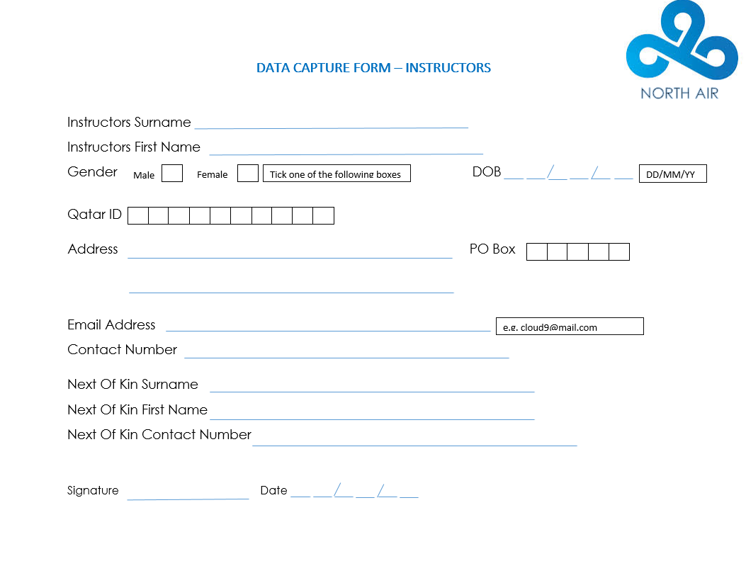

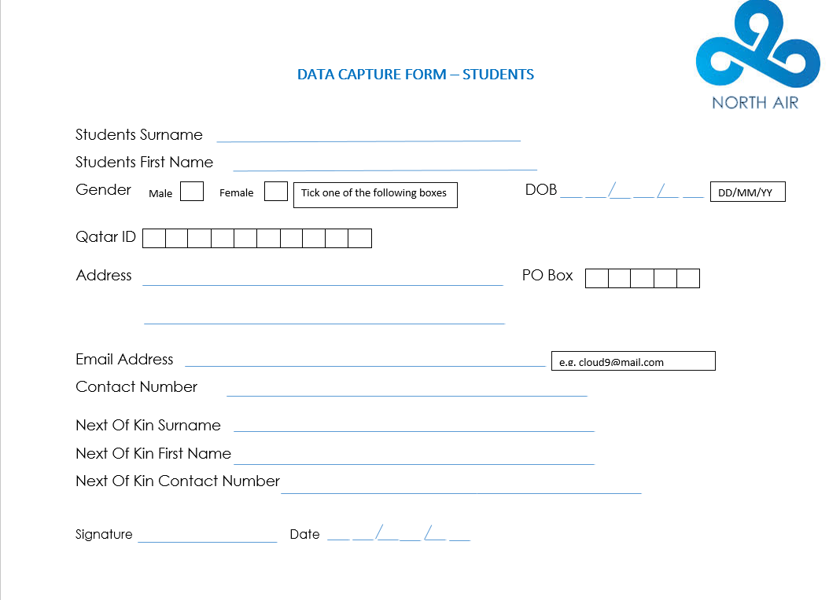

**Appendix B**

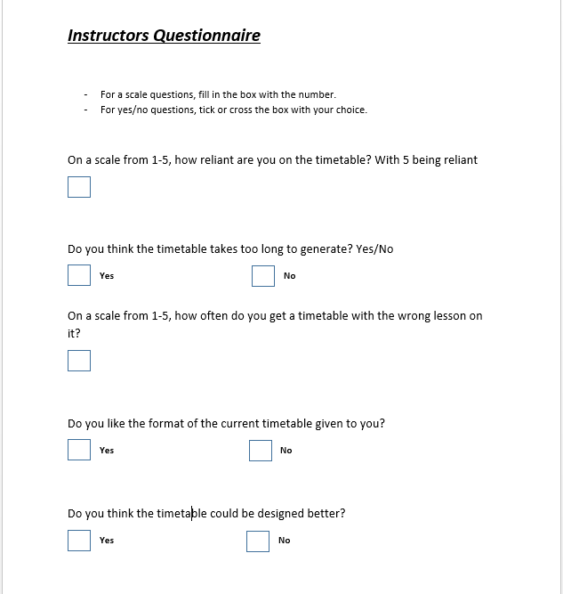

**North Air Booking System**



**USER MANUAL**

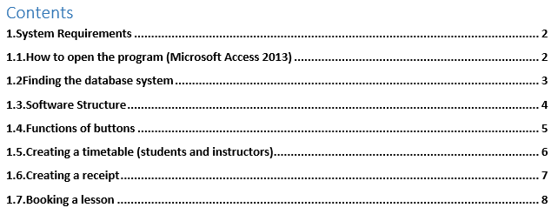

# 1.System Requirements

In order to start using the system, you will have use the appropriate hardware and software to run the system. It is also important that the specification of the computer meets the basic requirements in order to be able to run the system smoothly. The software used is **Microsoft Office – Access 2013**. In this case the operating system is **Windows 7**. 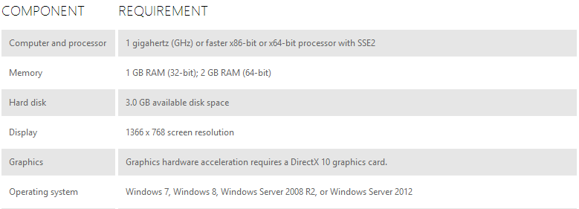

# **1.1.How to open the program (Microsoft Access 2013)**

Step 1 – Press the bottom left ‘Windows’ logo  
Step 2 – Click on ‘All Programs’  
Step 3 – Find the ‘Microsoft Office’ folder and from there, Microsoft Access.

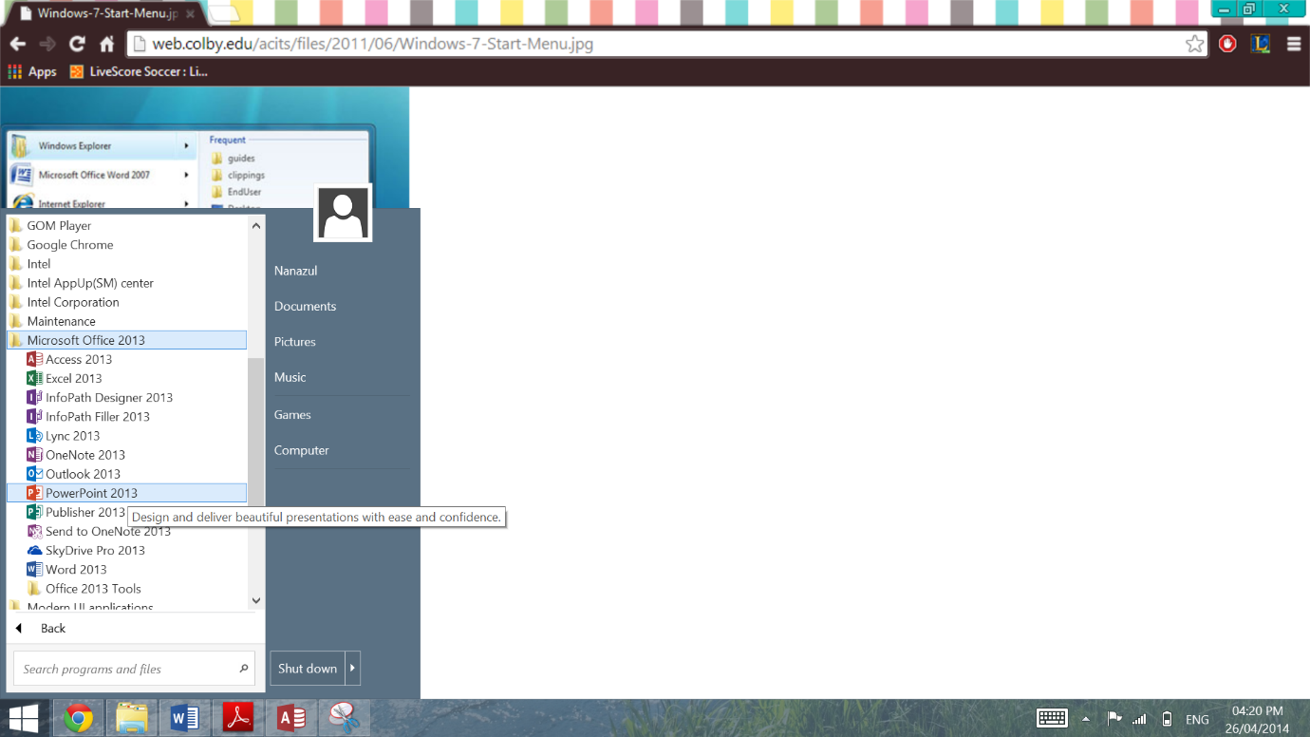

# 1.2Finding the database system

Once the program is opened, you’ll need to locate the database file.

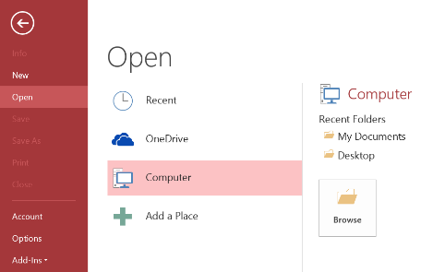Step 1 – On the program, click on Open -> Computer -> Browse

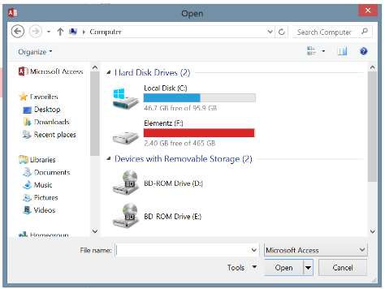Step 2 – On the search box, type in NorthAir Booking System to locate the database system.

# 1.3.Software Structure

Below is the basic structure of the database system (Microsoft Access 2013).

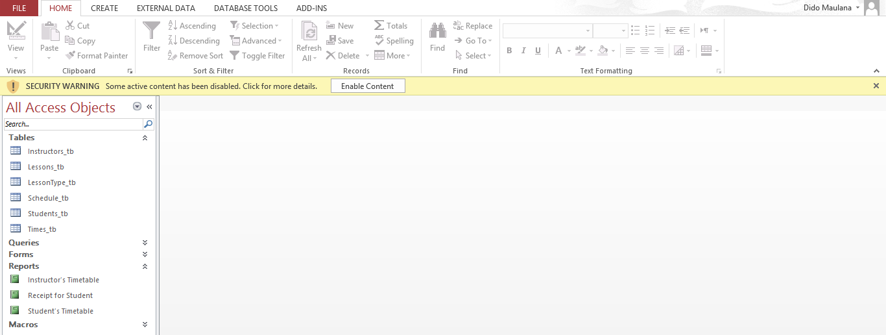

The topside toolbar is your main resource system to edit things like the font, size, color etc. Most of the features available are accessible from the topside toolbar.

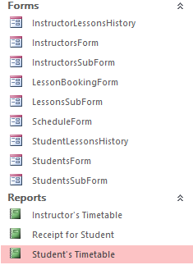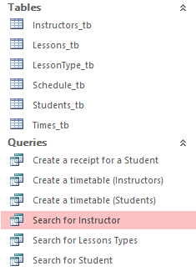

This is the All Access Object sidebar. It is where the user can access the database, forms, queries and reports.

# 1.4.Functions of buttons



Button to close the form you are currently on.

Help button that gives you an explanation of what kind of data entry form you filling in



Button that will redirect you to the first record available on the database for that certain form you are filling in. E.g. Student Entry Form, pressing this button will link you to the first student with ID 1.



Button that will redirect you to the last record available on the database for that certain form you are filling in. E.g. Student Entry Form, pressing this button will link you to the last student.



Button that will redirect you to the previous record available on the database for that certain form you are filling in. E.g. Student Entry Form, pressing this button whilst on Student #2 record will link you to Student #1’s record.

Button that will redirect you to the next record available on the database for that certain form you are filling in. E.g. Student Entry Form, pressing this button whilst on Student #1 record will link you to Student #2’s record.

Button that will delete the record you are currently on or the record you are filling in. Known as the ‘Delete Record’ button.

Button that will save any modification to an existing record or a new record that you finished filling in. Known as the ‘Save Record’ button.



Button that links you to the lesson booking form. This button is only available on the Schedule Form where you check if the student’s desired schedule is available.

# 1.5.Creating a timetable (students and instructors)

STEP 1 – Click on the ‘Student’s Timetable’ report.

STEP 2 – A parameter box value will open asking you to enter Student ID, Student Surname, and Student First Name (Not all of them has to be filled in, if you know your student ID, it is fine to not fill in the next boxes that pops up.)

STEP 3 – A list of lessons of the entered student should pop up

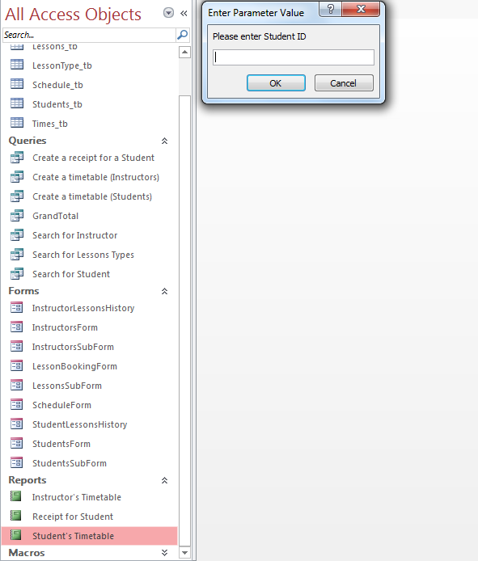

2

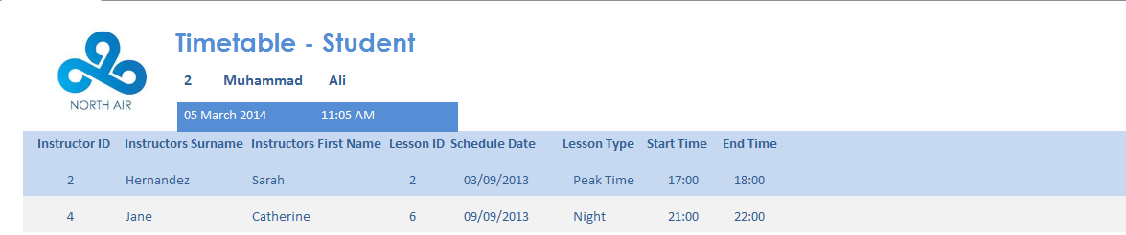

3

1

# 1.6.Creating a receipt

STEP 1 – Click on the ‘Receipt for Student’ report.

STEP 2 – A parameter box value will open asking you to enter Student ID, Student Surname, and Student First Name (Not all of them has to be filled in, if you know your student ID, it is fine to not fill in the next boxes that pops up.)

STEP 3 – A list of lessons of the entered student should pop up

1

2

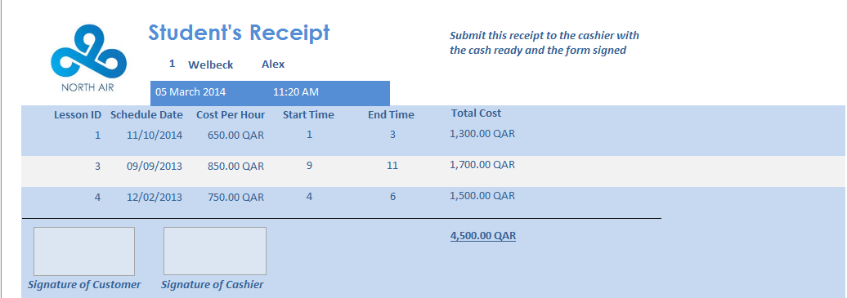

3

# 1.7.Booking a lesson

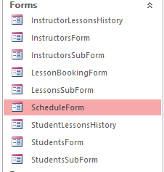

1

Step 1 – On the ‘All Access Objects’ sidebar, you will find the tab called Forms. If the forms as shown in the picture doesn’t show, click it to expand.   
  
Step 2 - Open the Schedule Form.

Step 3 – On the Schedule Form, enter the desired date to check whether the times asked for are available.

Step 4 – If it is, press the ‘Make Booking’ button to proceed.

2



4

3

This table shows the lessons that are already set up on that certain day.   
User must make user that the times are not taken before proceeding to the next step

Enter the desired date on the box below.

Step 5 – After pressing the ‘Make Booking’ button, it will bring you to the ‘Lesson Booking Form’, fill in the required details as shown below.

Step 6 – Press the button to save the record which will be automatically entered onto the database.



The ‘Student Detail’ box shows you the details of the student whom ID you have entered into the form

The ‘Instructor Detail’ box shows you the details of the instructor whom ID you have entered into the form

6

5